Step 1.

After logging into my non-root admin account, I used the search bar at the top of the AWS services page to locate the s3 page which contains all the bucket information to use for step 1 of the lab assignment.

Figure 1 - S3

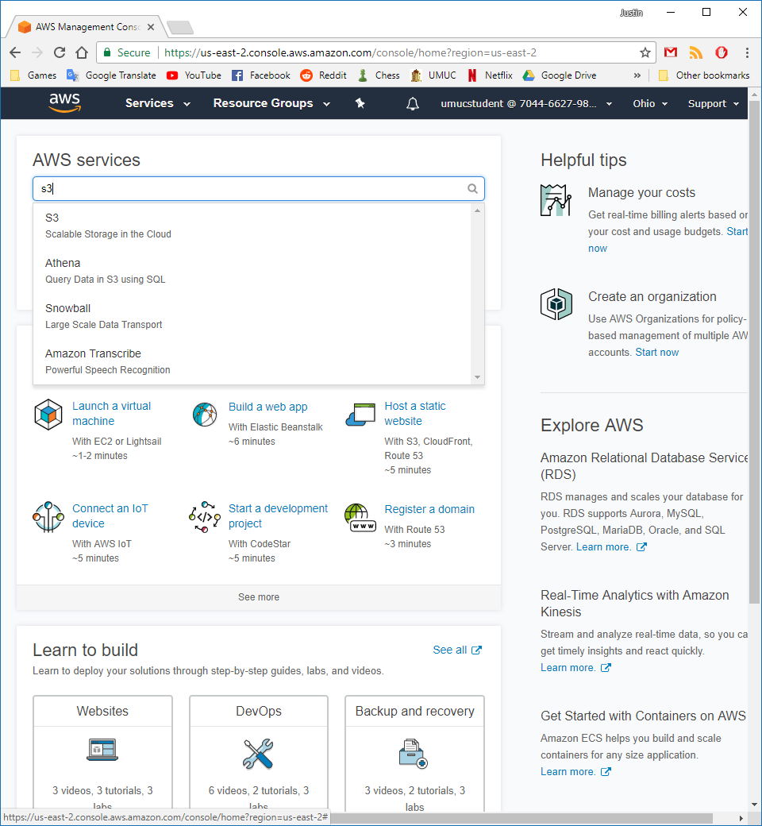

Once on the Amazon S3 page, I click the “Create bucket” button to create a new bucket. One problem that I did run into was that the bucket name cannot contain uppercase letters, and in the lab assignment we were told to name our bucket “SDEV400HW2YourName”. I had to use all lower-case letters for this to work properly.

Figure 2 - Error using Bucket name

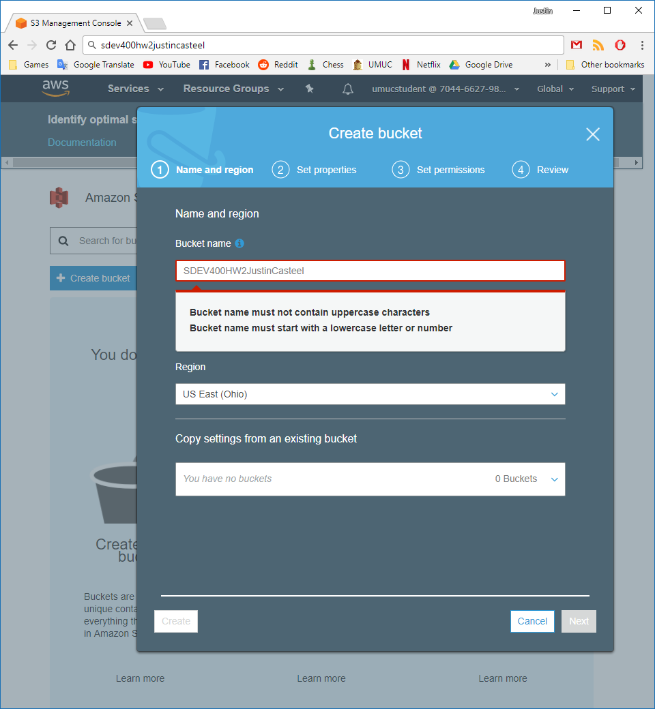

Figure 3 - No Bucket name error

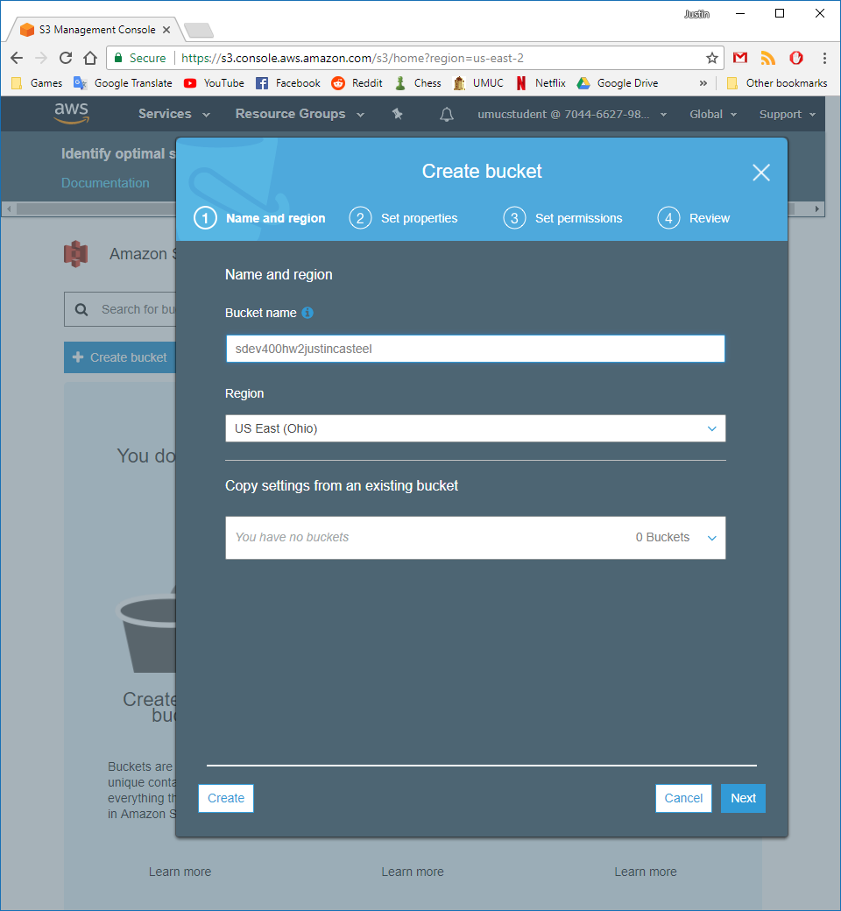

Successfully created the S3 bucket with the following properties, permissions, and management options.

Figure 4 - Bucket properties

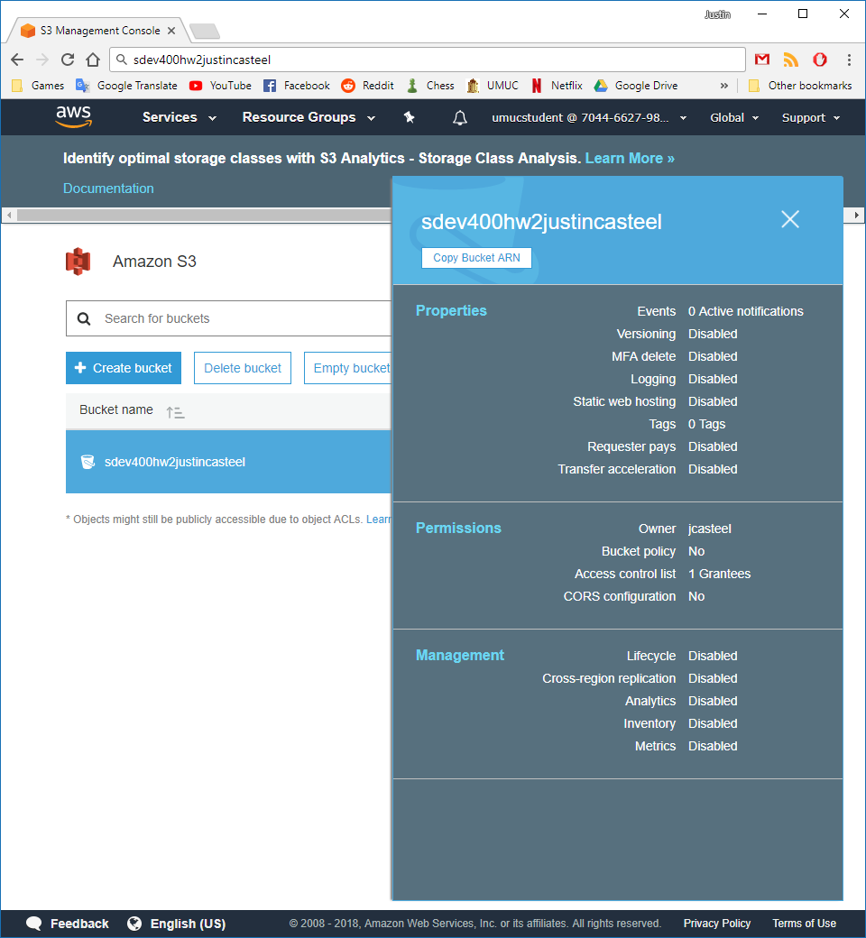

I then went into the newly created bucket and clicked the “Create folder” button to create 4 new folders, as follows: Admin, Faculty, Presentations, and Students.

Figure 5 - New Folders

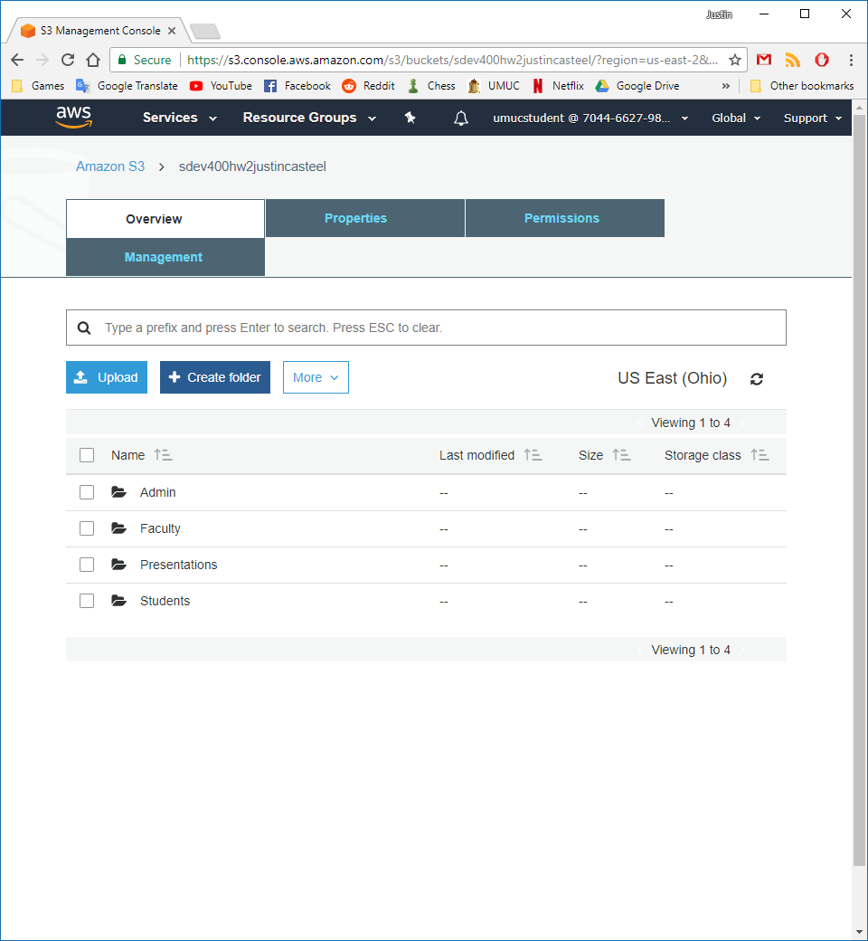

Step 2.

I created a notepad document and used the AWS CLI “cp” command to copy 4 pictures from my desktop to the 4 directories: Admin, Faculty, Presentations, and Students. The batch file and notepad file are included in my submission. What each line of text is doing is that it is telling AWS to go into Amazon S3 where our bucket is located from before and then we tell it to use the “cp” command which stands for copy when using AWS. We then tell it what we would like it to copy and note that it is going to try and find these documents on our desktop, so we make sure they are available. After telling it which pictures we would like to copy we tell Amazon S3 where we would like these files copied to. So, we provide the bucket name and the 4 directories that we created earlier. We start by using the syntax s3:// and then provide our bucket name followed by / and then the directory followed by / and what we would like to name each of the files. I have left the file names the same in each directory to make it cleaner and easier to follow and keep organized. The last 4 commands use the AWS ls command which stands for list. So I told it to find the bucket directories I made previously and it lists all of the files that are currently in those directories.

Figure 6 – Batch file commands and images used for uploading

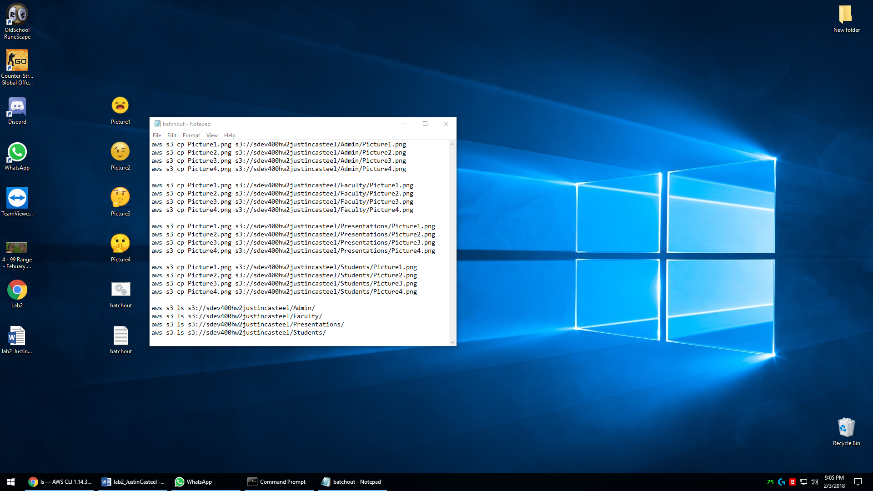

I saved this document as “batchout.bat” and executed it through the command prompt as shown below.

Figure 7 - batchout.bat executed part 1

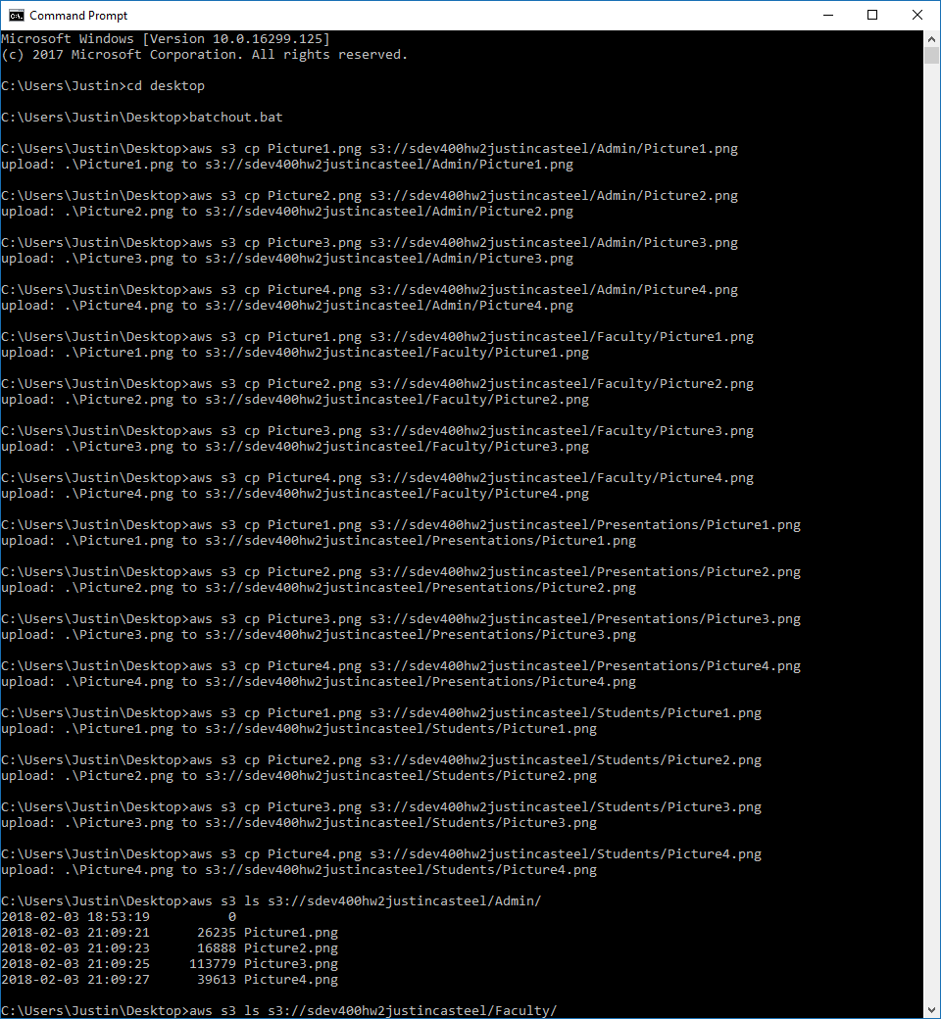

The image below shows the remaining commands of the batch file, which show all the files that we have just uploaded in their appropriate directories.

Figure 8 - batchout.bat executed part 2

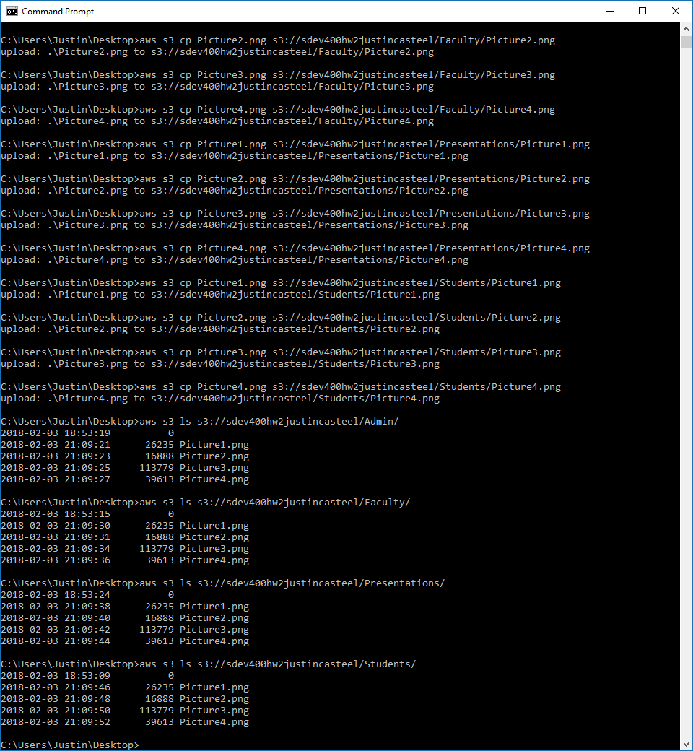

Step 3.

The first step I took was I created two new groups, one named instructor and the other named student. I did this because two of the students have the exact same permissions, so they will be able to be in the same group, and the instructor has slightly different permissions, so they will be in their own group.

Figure 9 - New user group “instructor” and “student” are created.

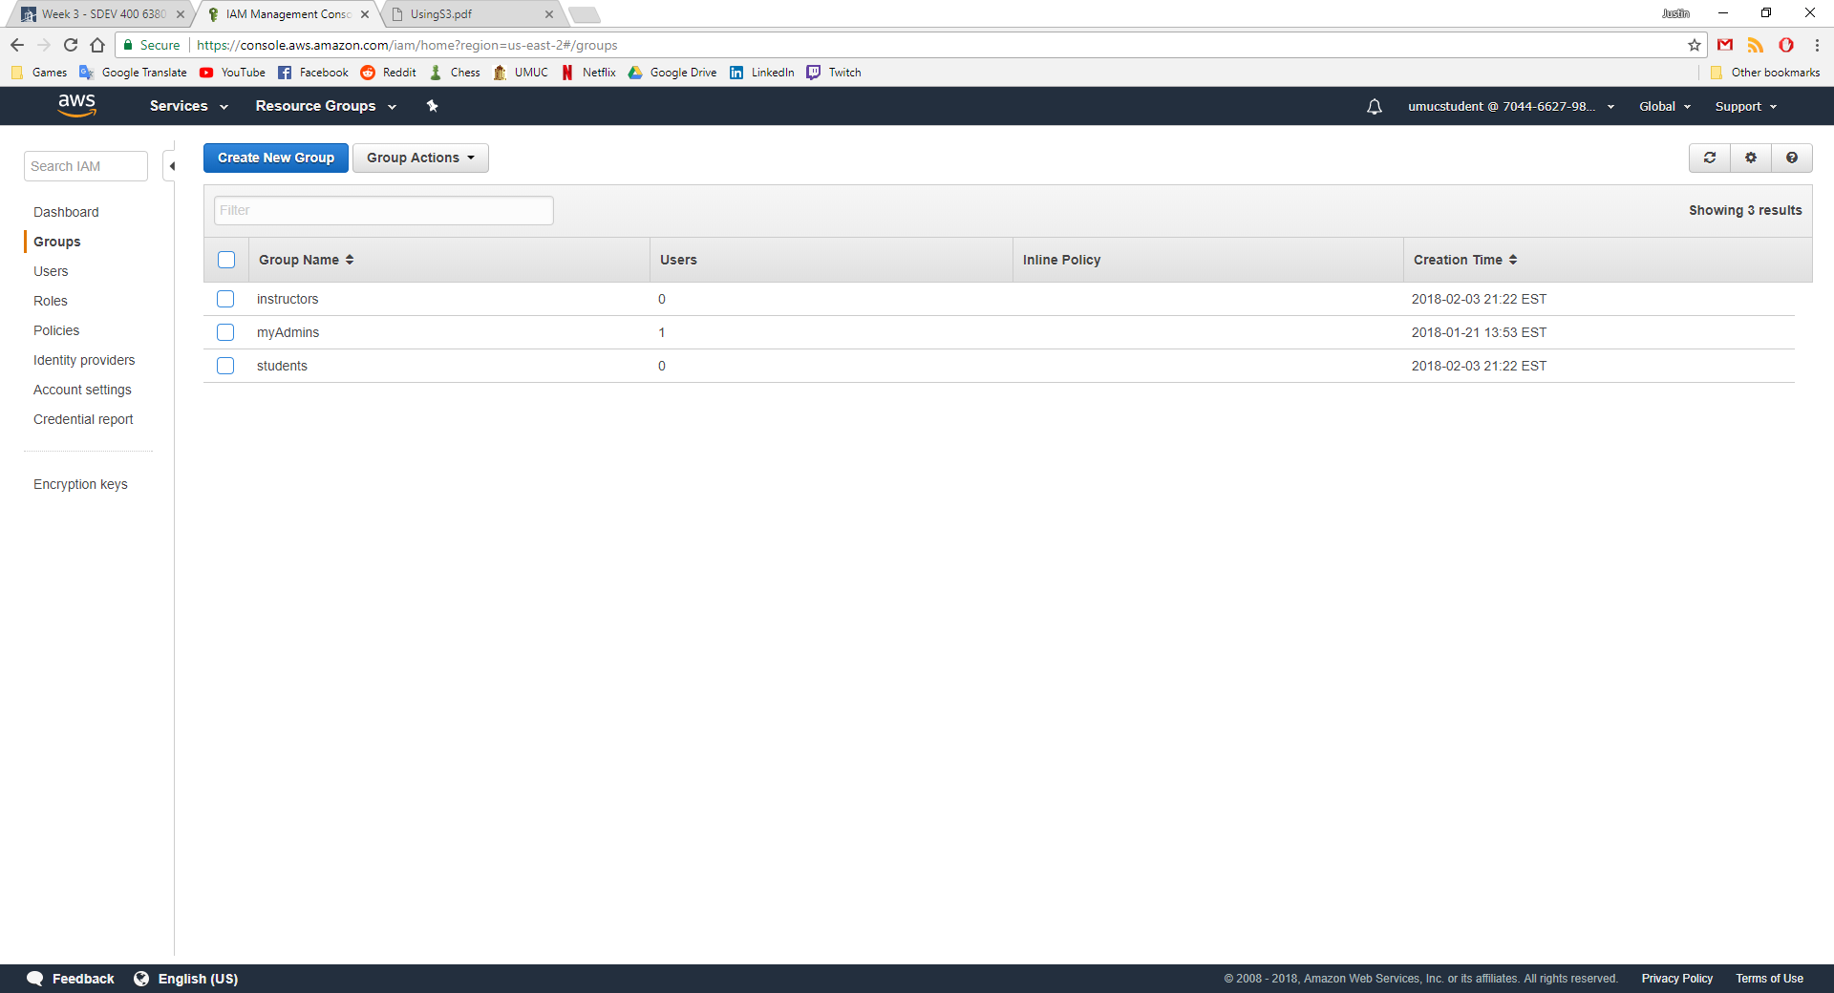

Next, I created the two user accounts, Jenny and Johnny. I am using the instructor account from week 1.

Figure 10 - New users Jenny and Johnny are created

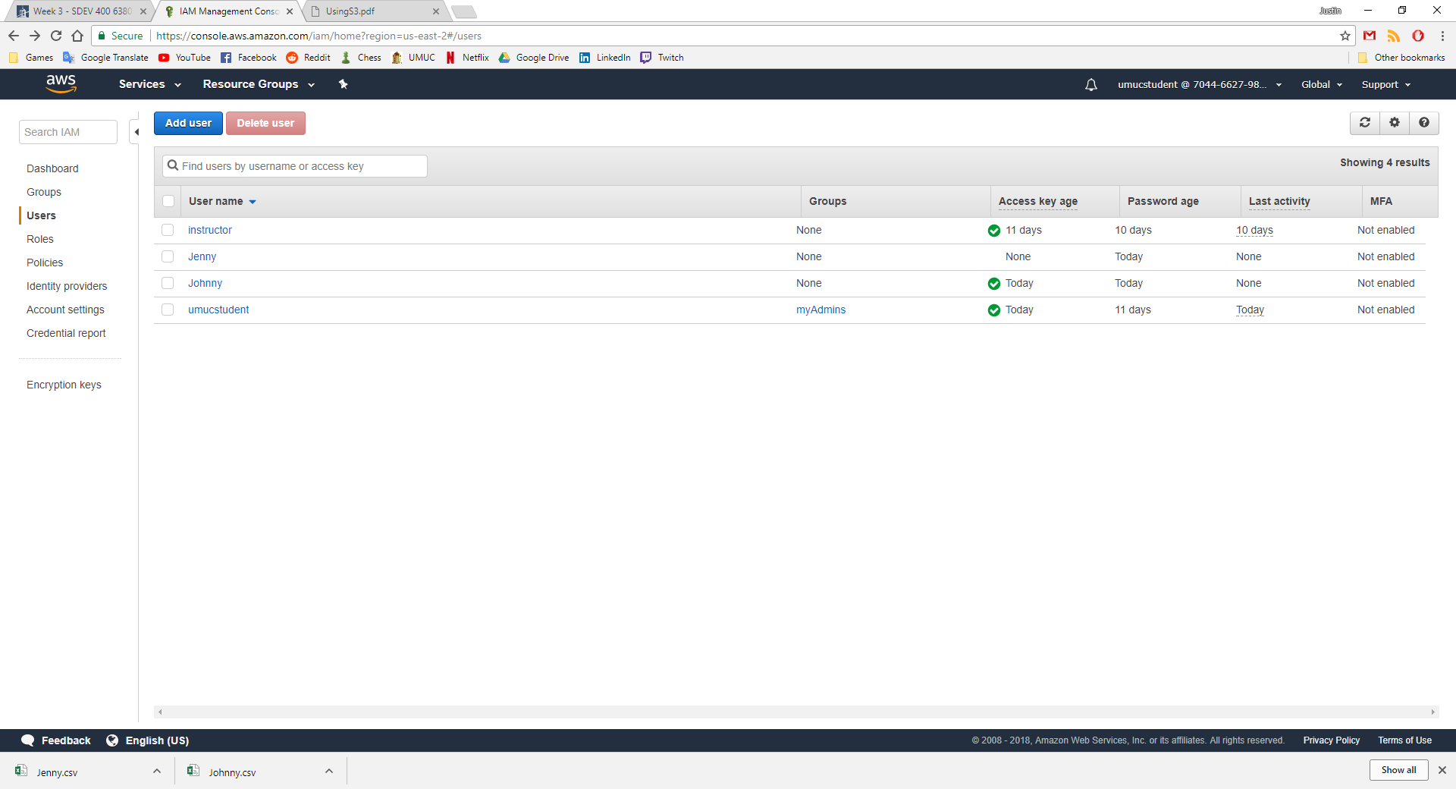

The image below shows the new account “Johnny” not being able to access any of the bucket folders because it has not been given any permissions. The Jenny and instructor accounts are both the same for now, since they also do not have any permissions to be able to view the bucket.

Figure 11 - Access denied

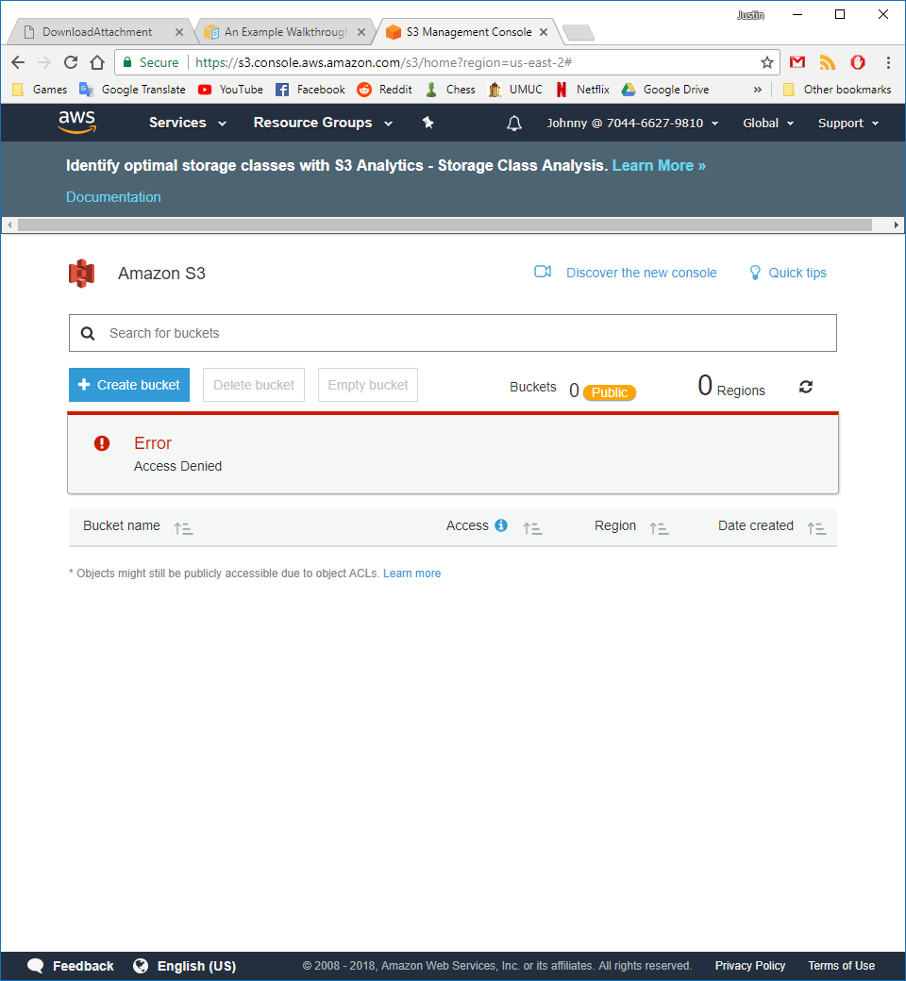

The first thing I did was create a policy that allowed anyone in the group to view the entire bucket. I will restrict permissions later, but for now this lets the group view the bucket.

Figure 12 - View Bucket JSON

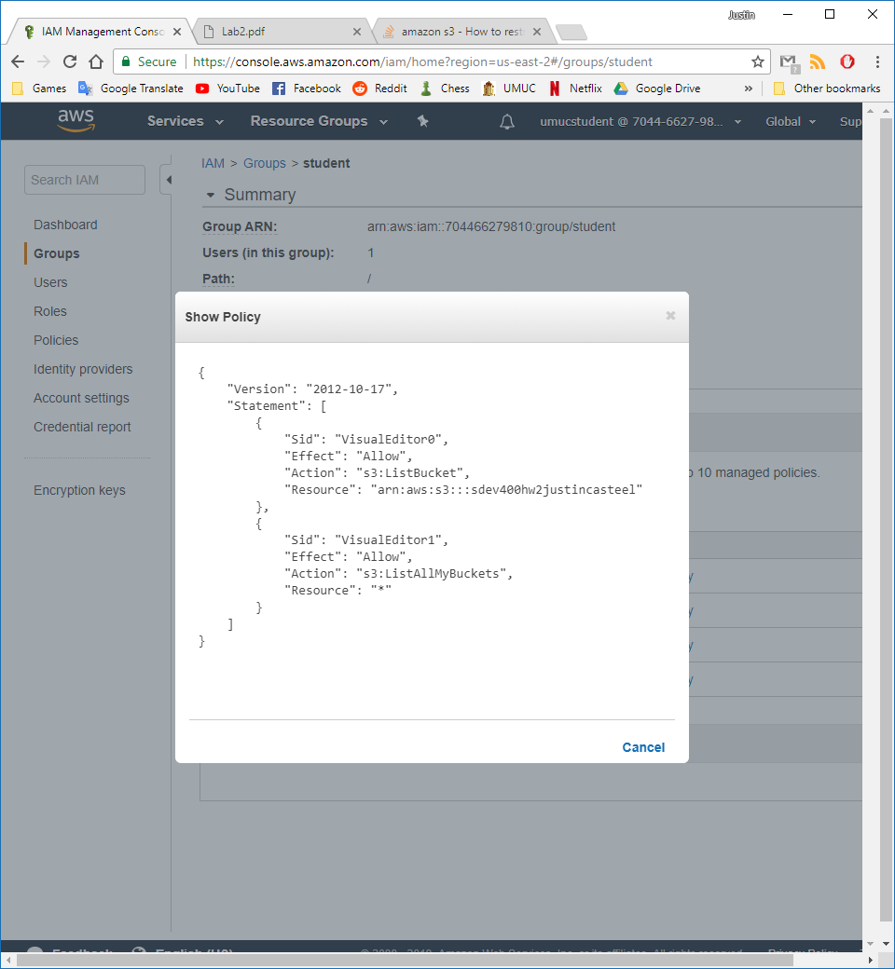

This allows users to see file names in folders but not view, download, or upload any files.

The second thing I did was create a policy called Students_YYY which gave access to the bucket and allowed the viewing of files and uploading of files to the Students folder only.

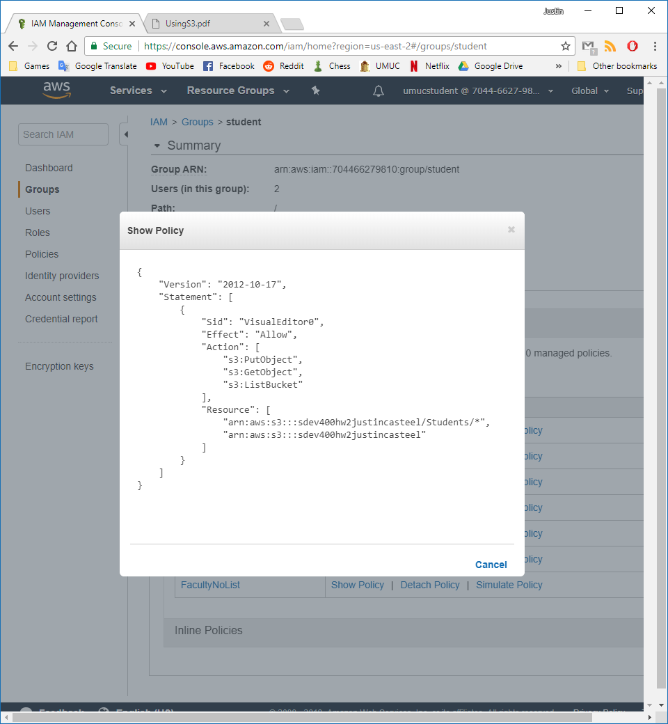

Figure 13 – Upload attempt to Presentations folder

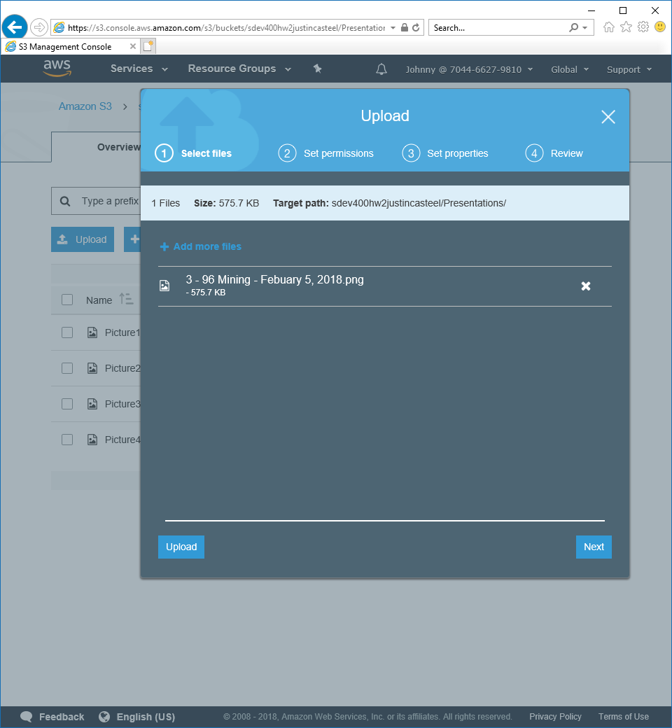

Figure 14 - Upload fails

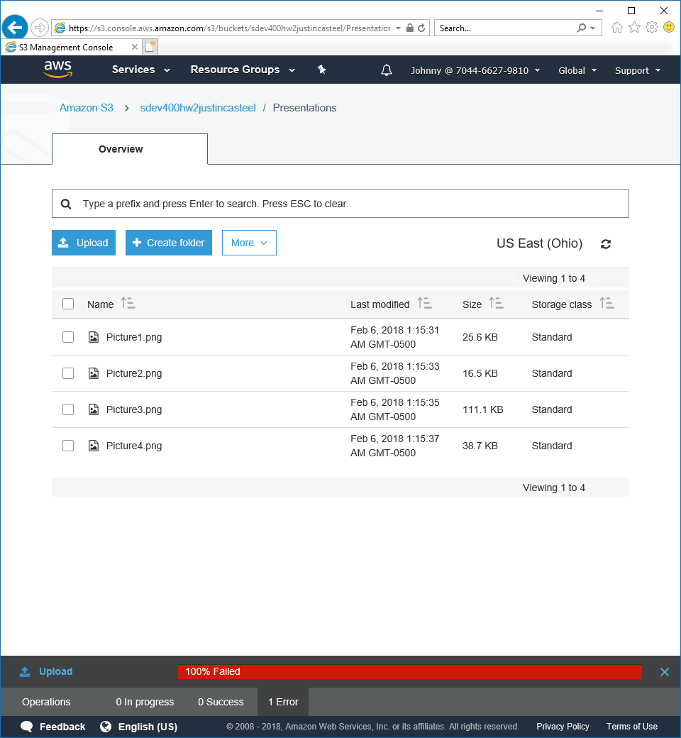

I then navigate to the Students folder where the user has upload permissions and successfully upload a file.

Figure 15 - Upload success

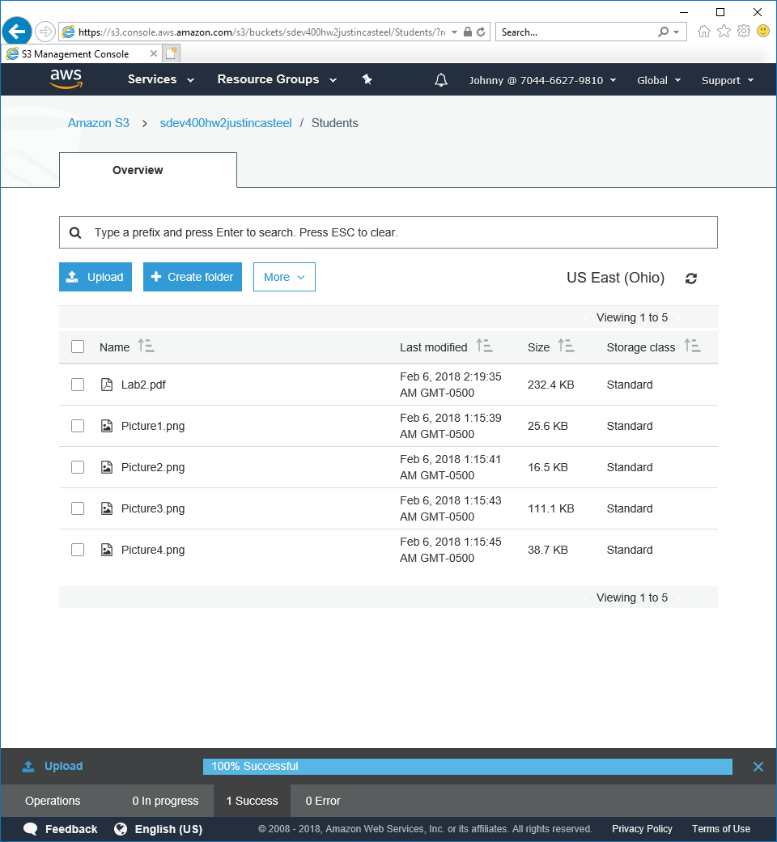

I am also able to open files from the Students folder but no other folders, shown below in figure 16.

Figure 16 - Open file properties

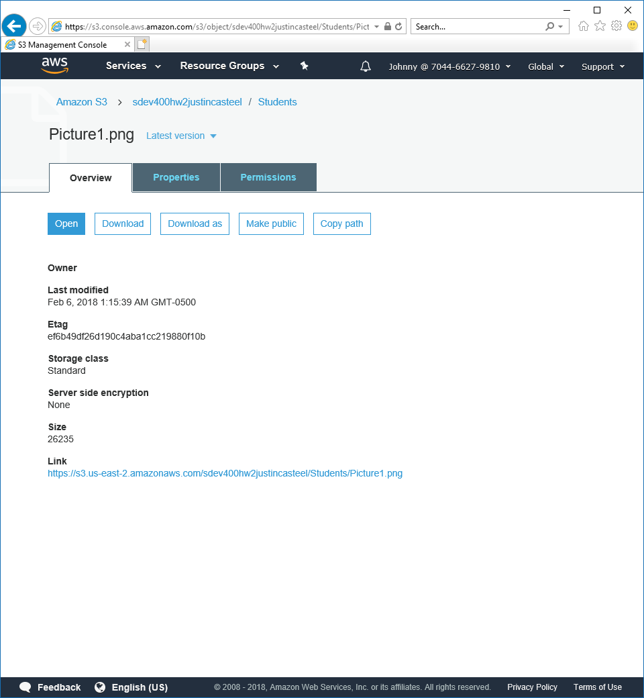

Figure 17 - Picture1

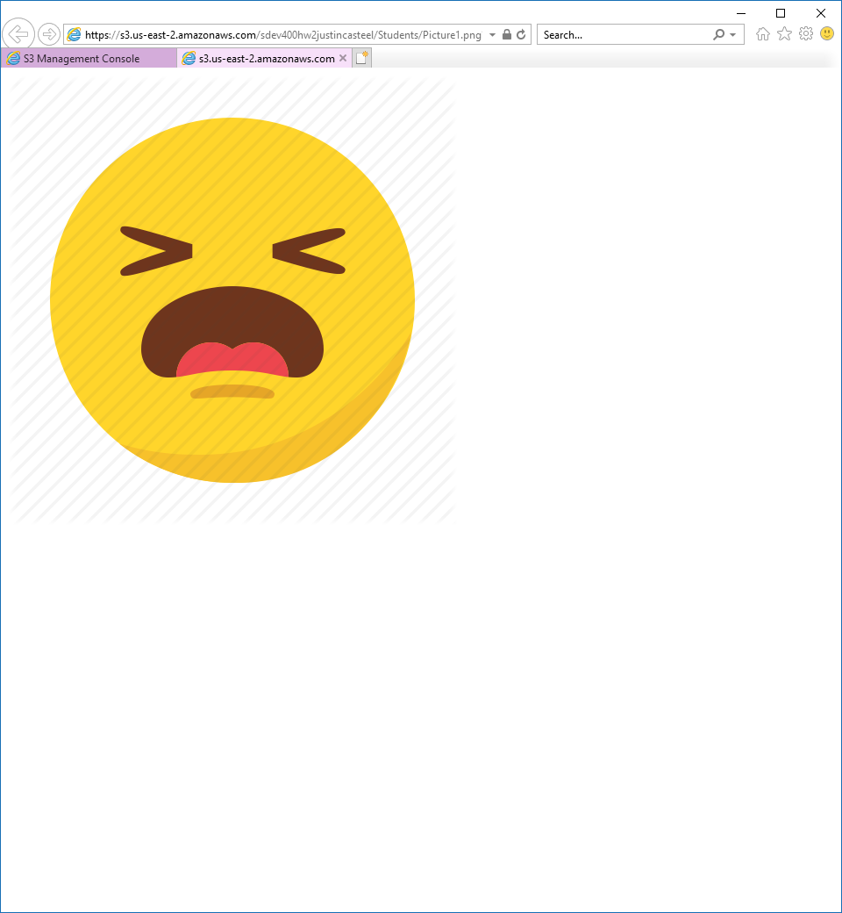

Figure 18 - Open file - Admin folder

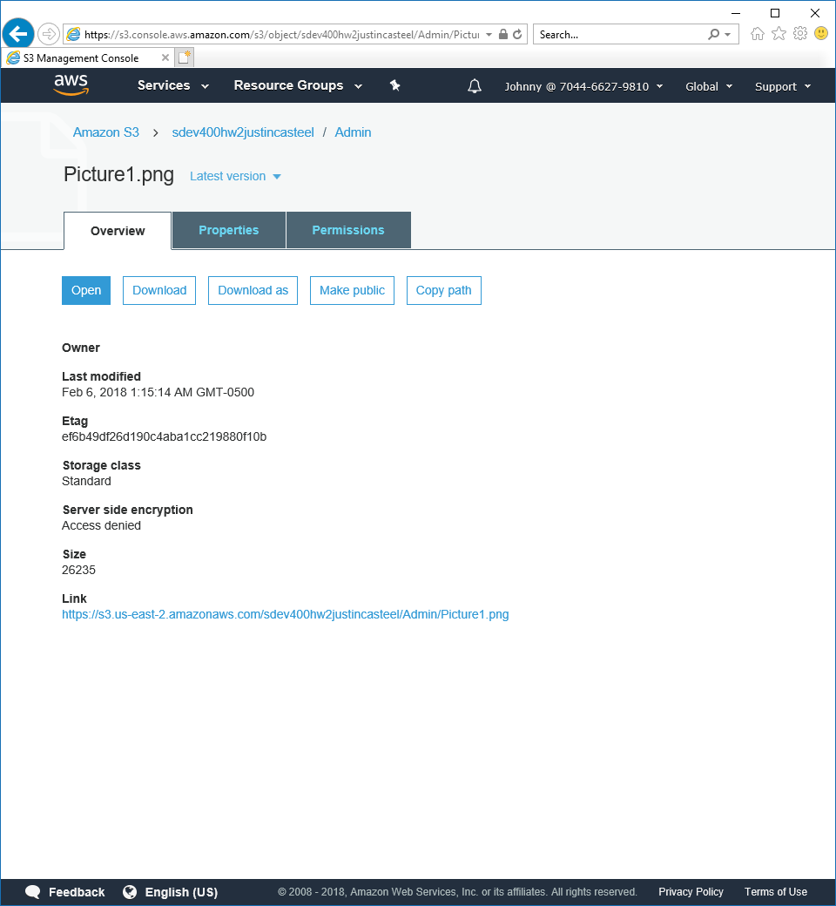

Figure 19 - Error when opening

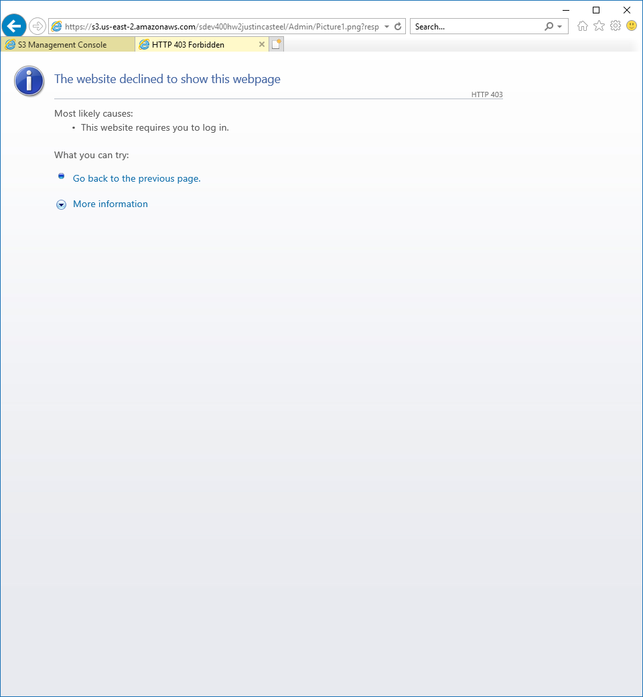

Next, I created two policies for the Student group under the Faculty folder. These were to deny list, write and read privileges. I created two policies, one containing the deny list policy and the other containing the deny read and write policy. The “FacultyNoList” policy makes it so any user in the attached policies group will not be able to view files from the folder specified. In this case that folder is the “Faculty” folder. See figure 22 for the error received.

Figure 20 - FacultyNoList

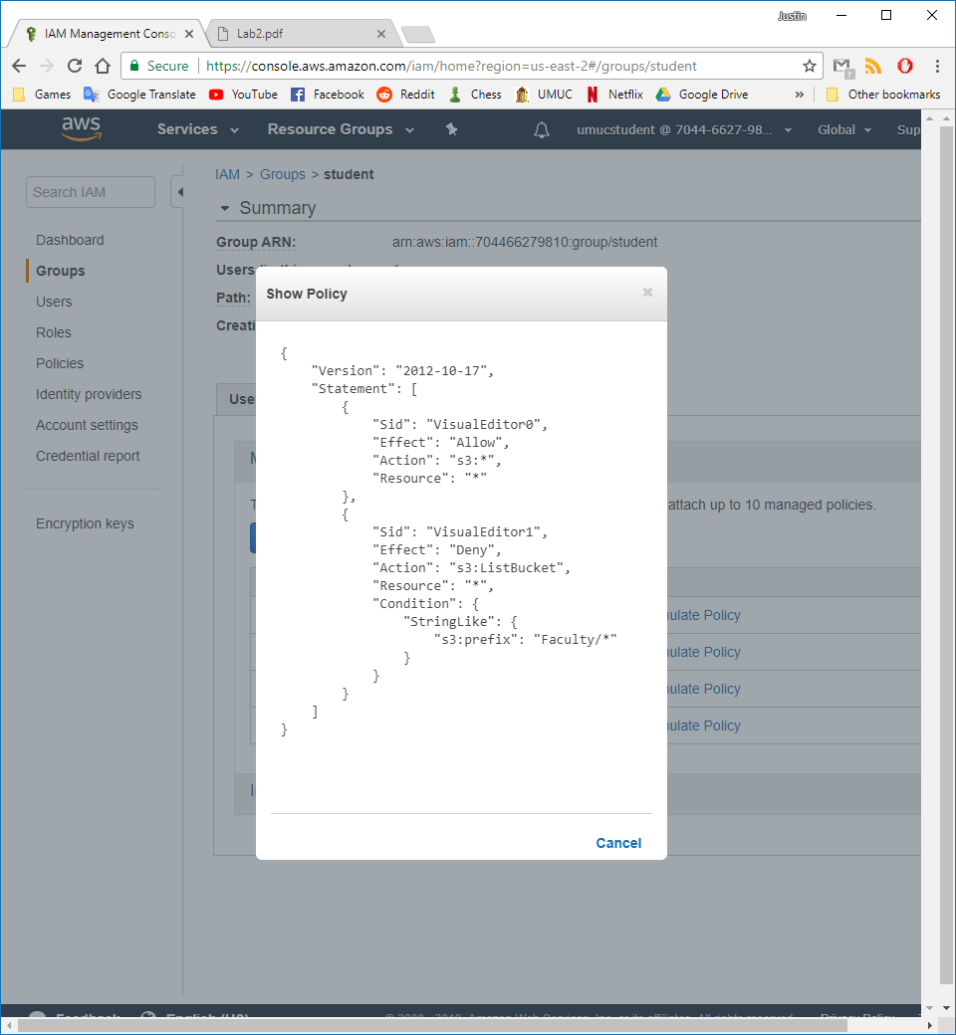

Figure 21 - Faculty_NNN

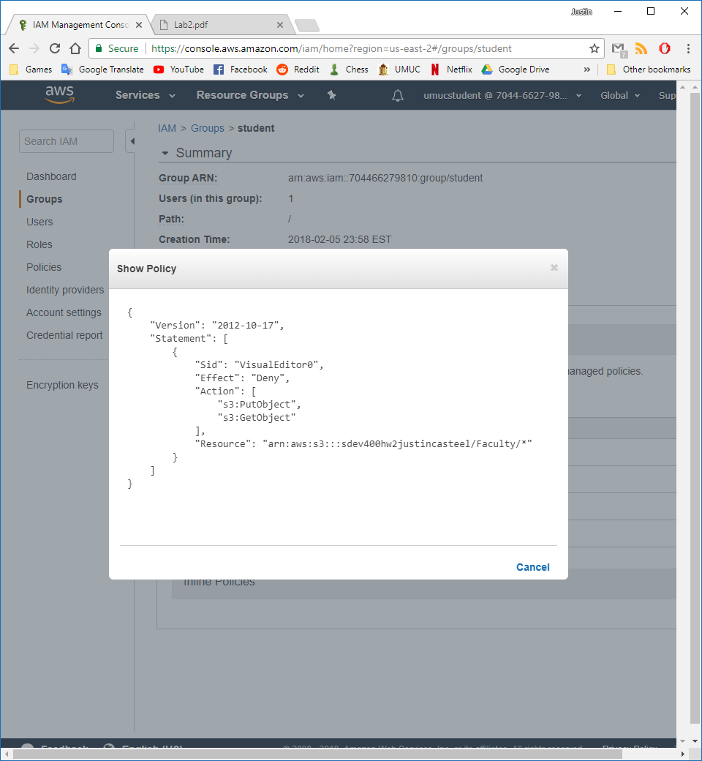

Figure 22 - Error when trying to view Faculty folder

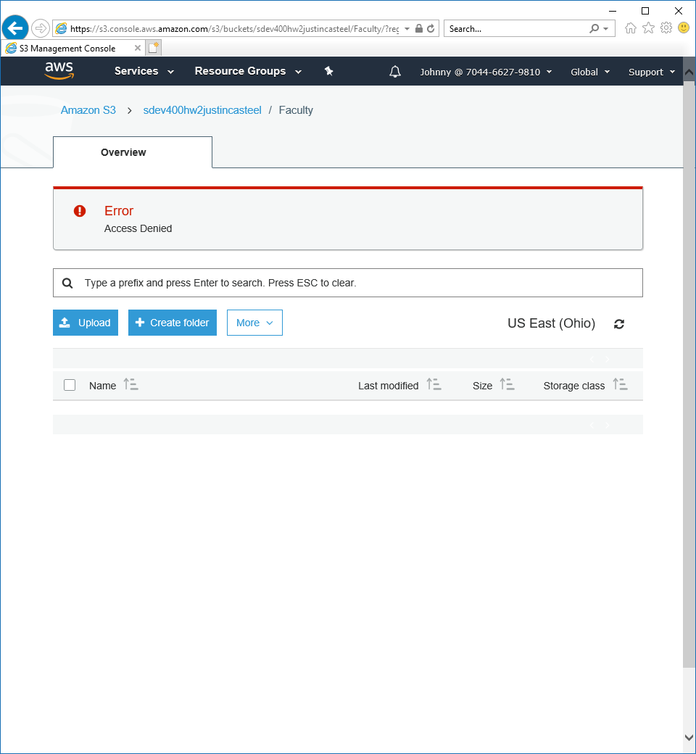

I created two exact copies of the Faculty policies for the Admin folder, so the Student group would not be able to see these as well.

Figure 23 - AdminNoList

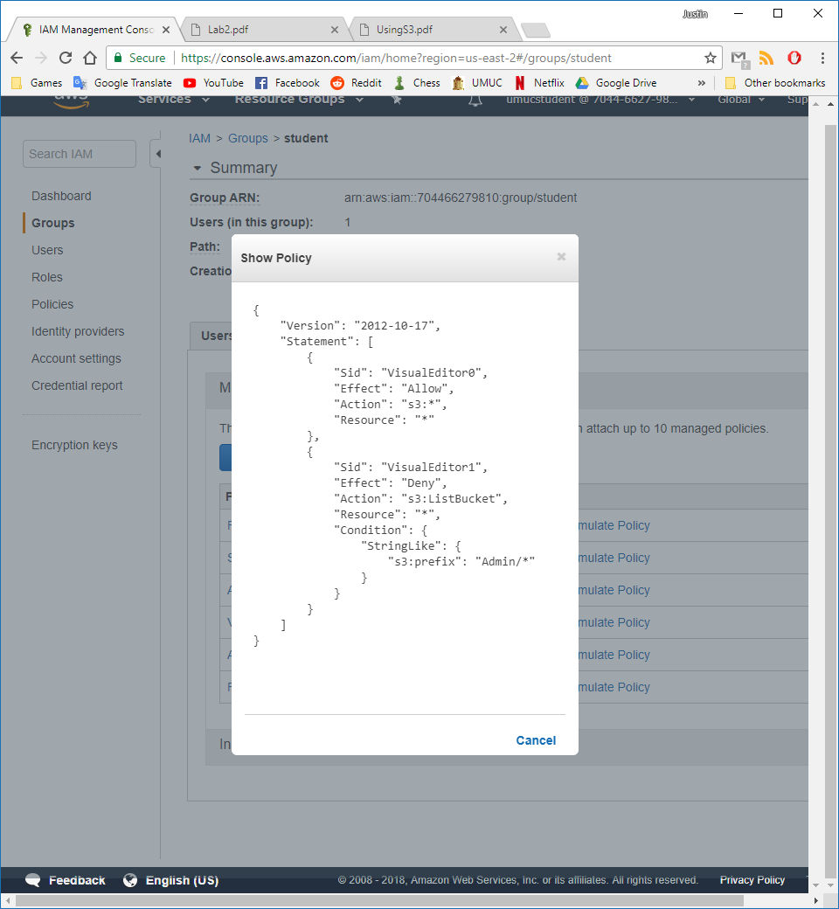

Figure 24 - Admin_NNN

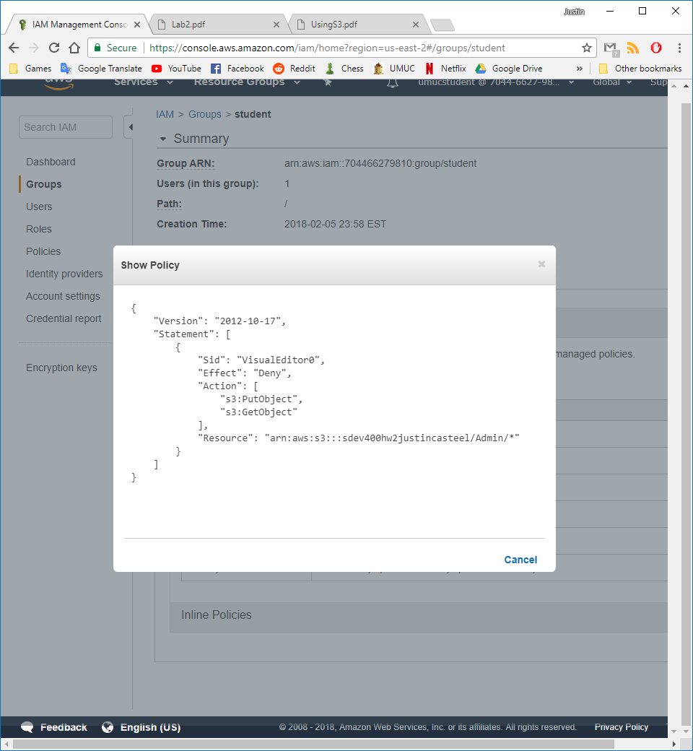

Figure 25 - Admin folder access denied

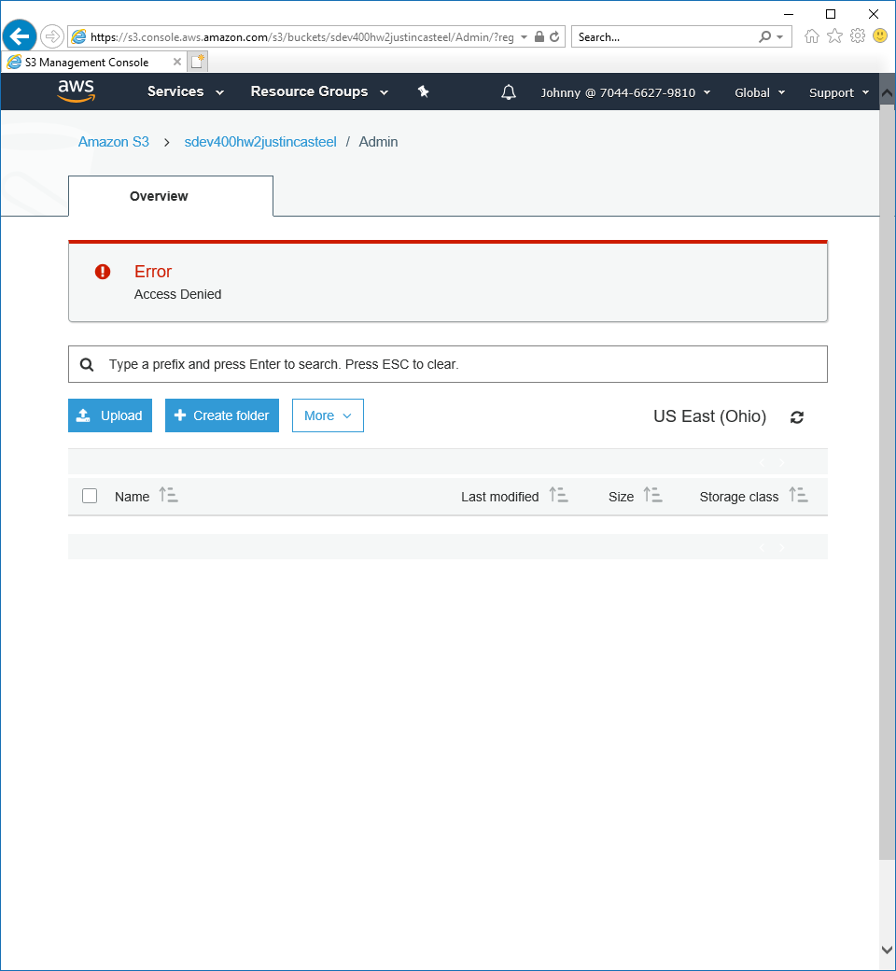

Figure 26 - Presentations_YYN policy

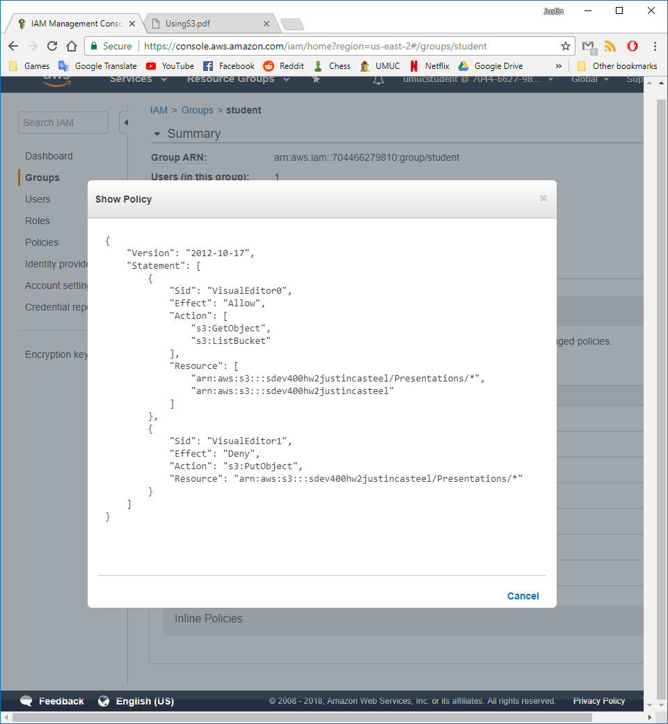

Figure 27 - Student Group policy list

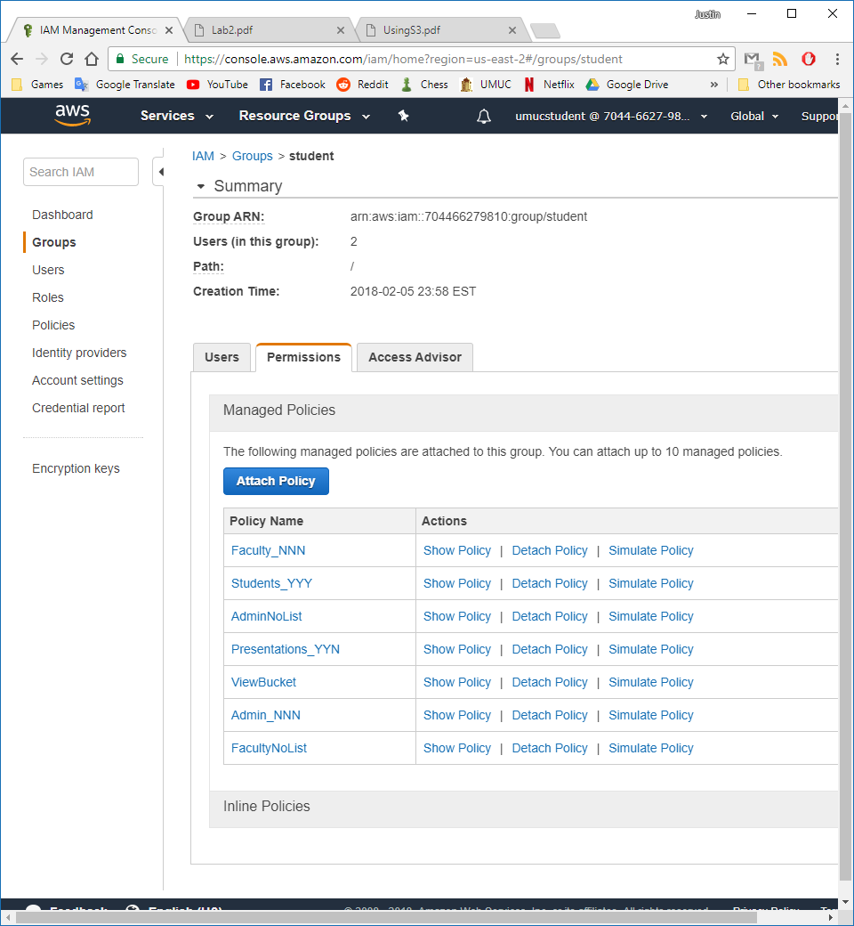

Figure 28 - Student Group Users list

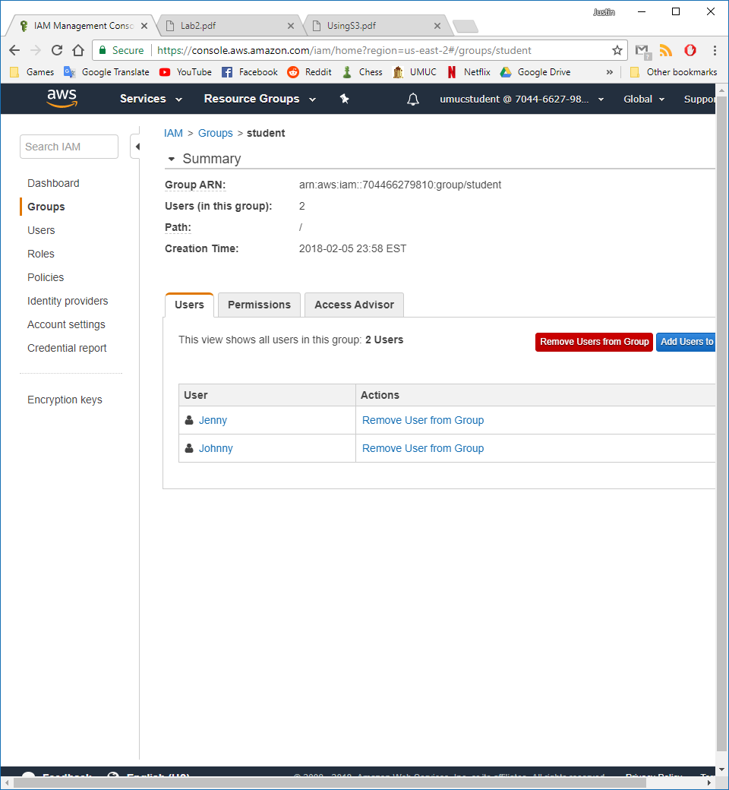

That is all the requirements for the Student group, we now move on to the instructor group and make the policies required. Since the presentation folder is the same policy for both the Student group and Instructor group, we can reuse that policy.

I started off by creating a policy that denies read and write privileges to the Students folder.

Figure 29 - Student_NNN

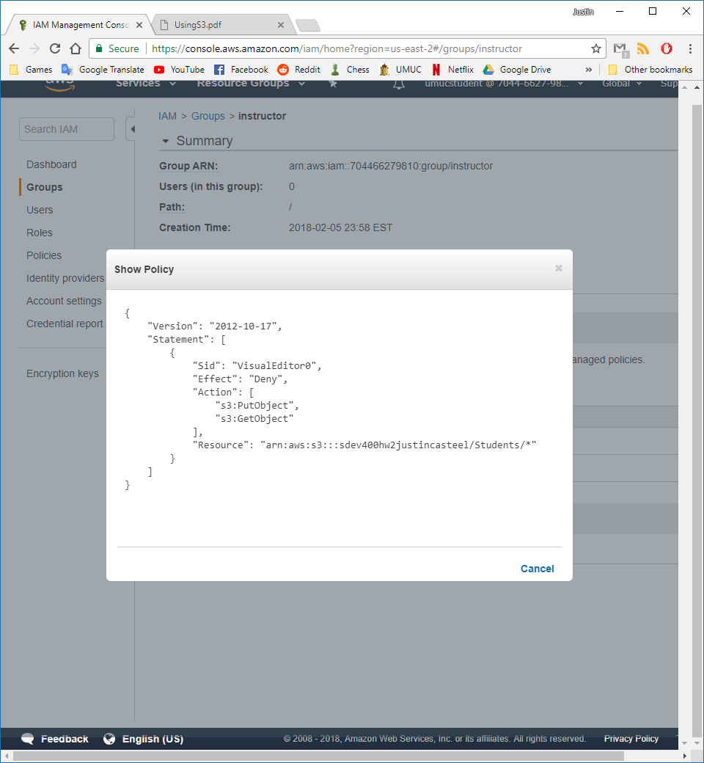

The next policy hides all the contents of the Students folder from the instructors group.

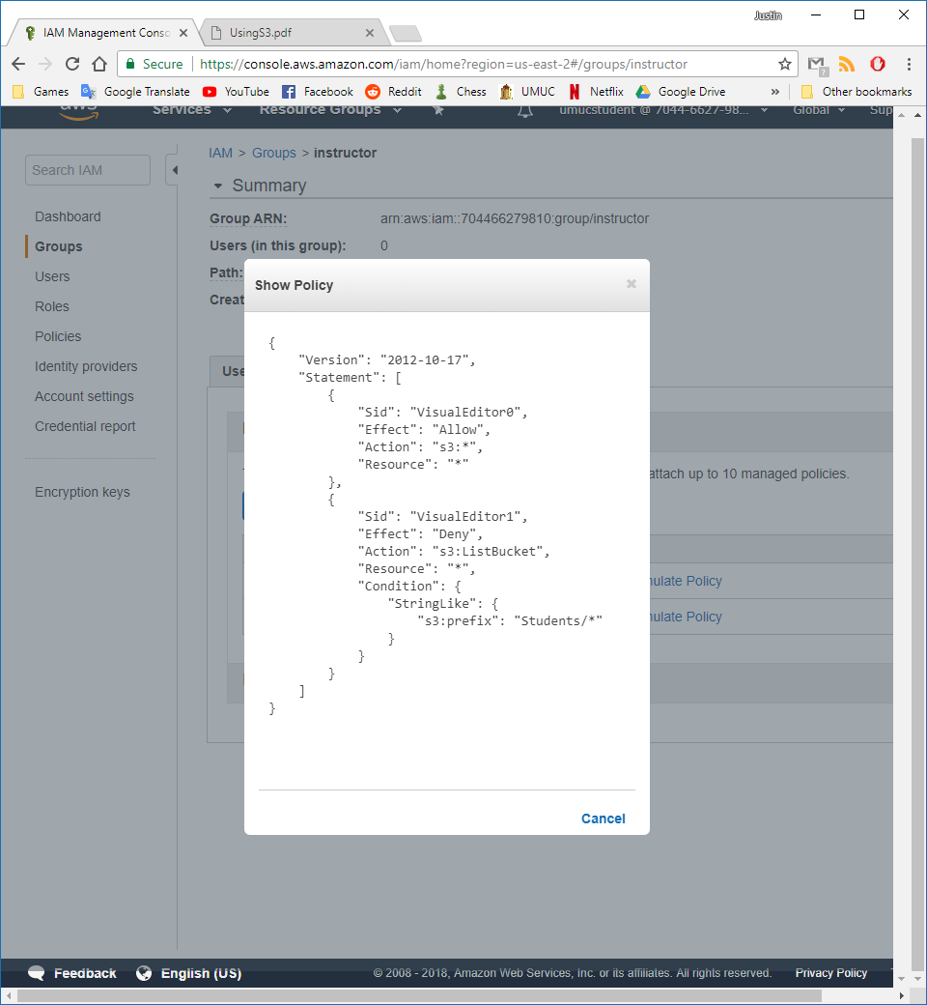

Then I created the Faculty_YYY policy which grants read, write, and list access to the group the policy is attached to.

Figure 30 - Faculty_YYY Policy

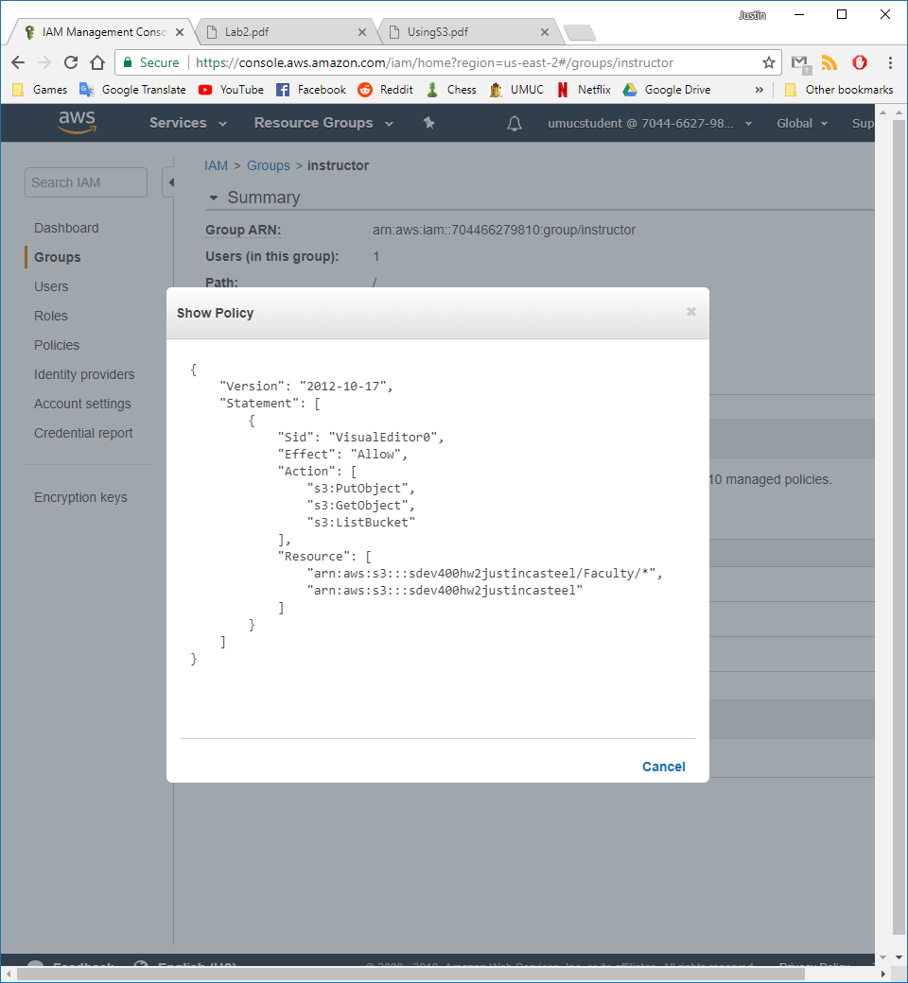

Then I create an identical policy called Admin_YYY that grants the same permissions as the Faculty_YYY policy.

Figure 31 - Admin_YYY policy

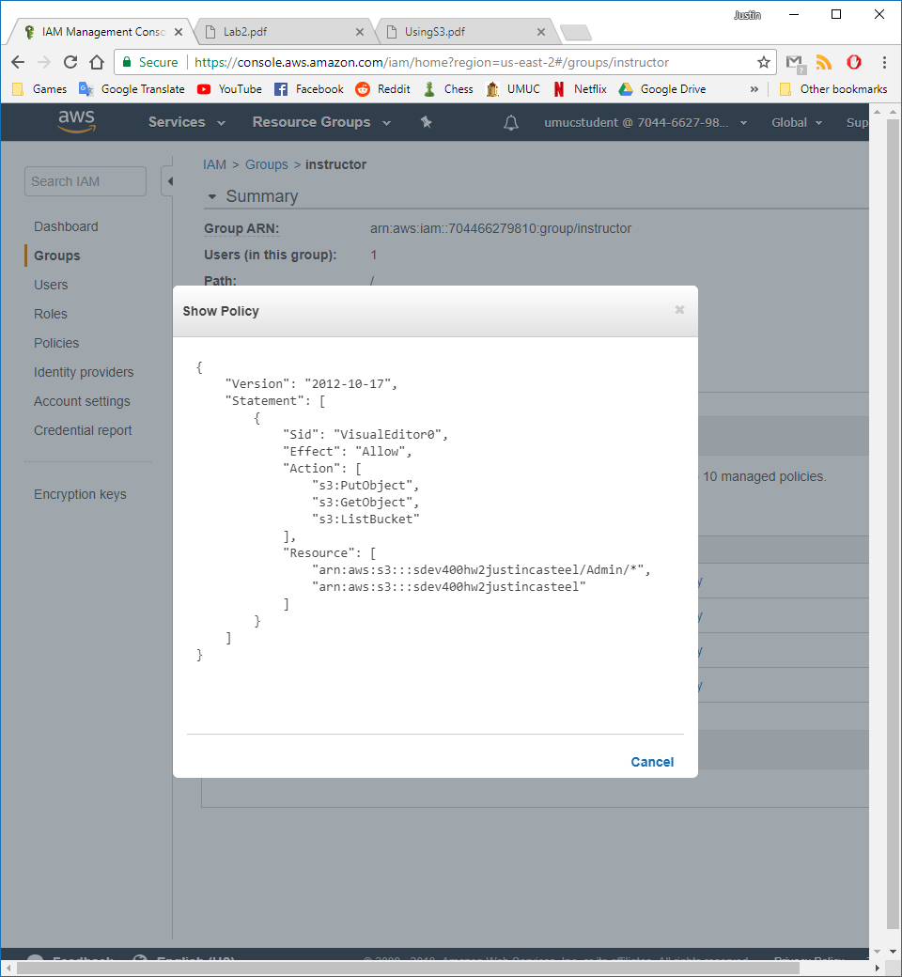

Then finally I attach the previously made Presentations_YYN policy to the instructor group.

Figure 32 - PResentations_YYN policy

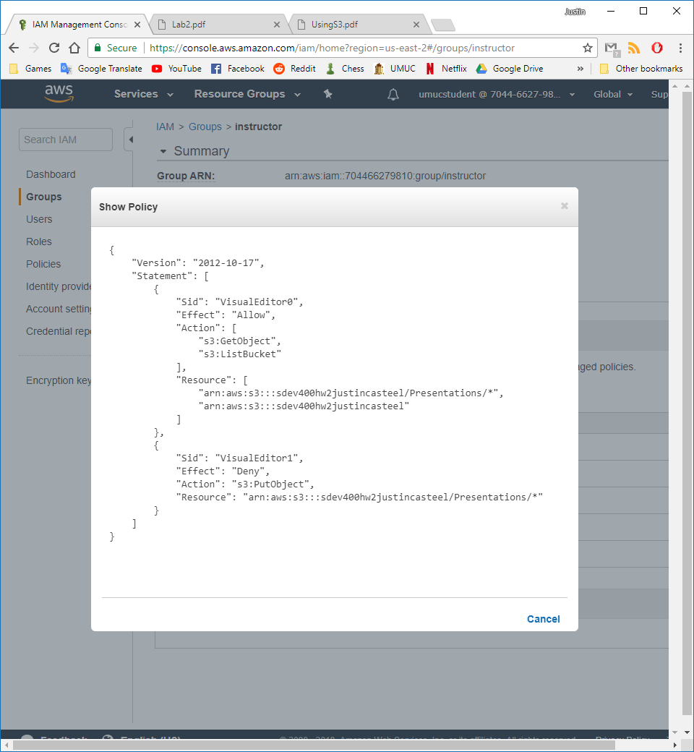

The final policies are shown for the instructor group below.

Figure 33- instructor policies

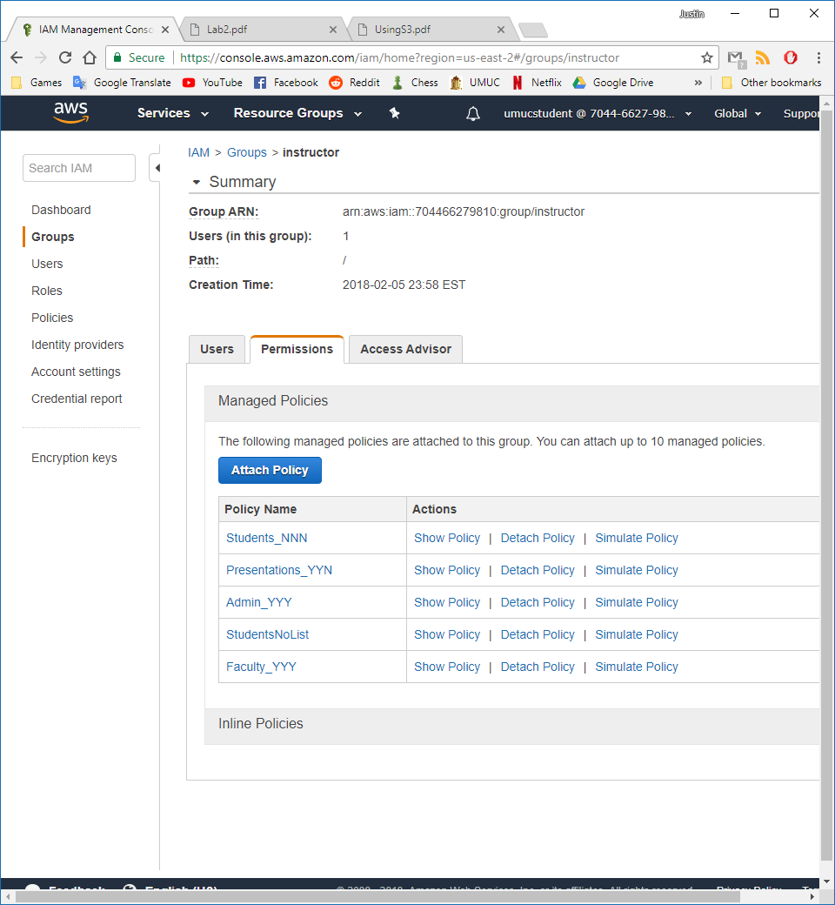

Figure 34 - instructor user list

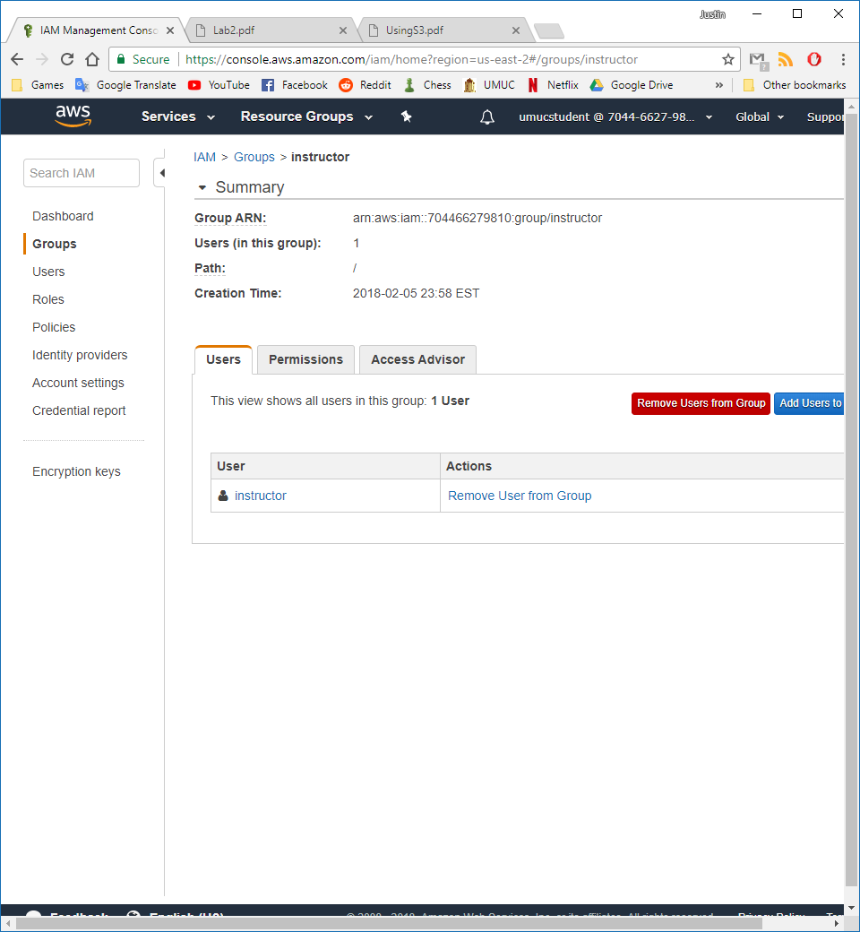

I now log into the instructor account to test the policies.

Figure 35 - Bucket shown

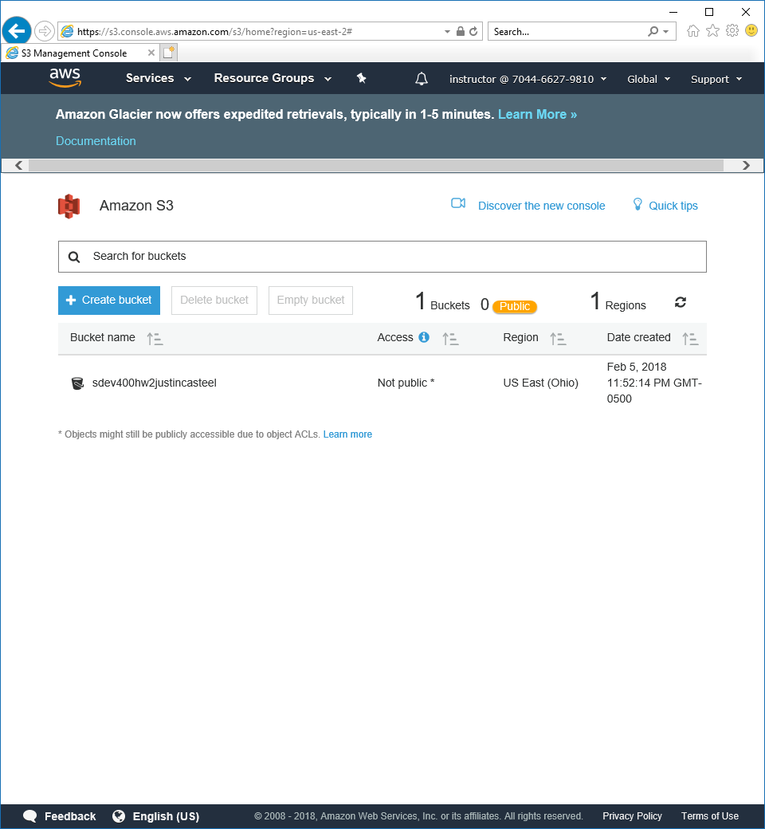

Figure 36 – Folders for instructor account

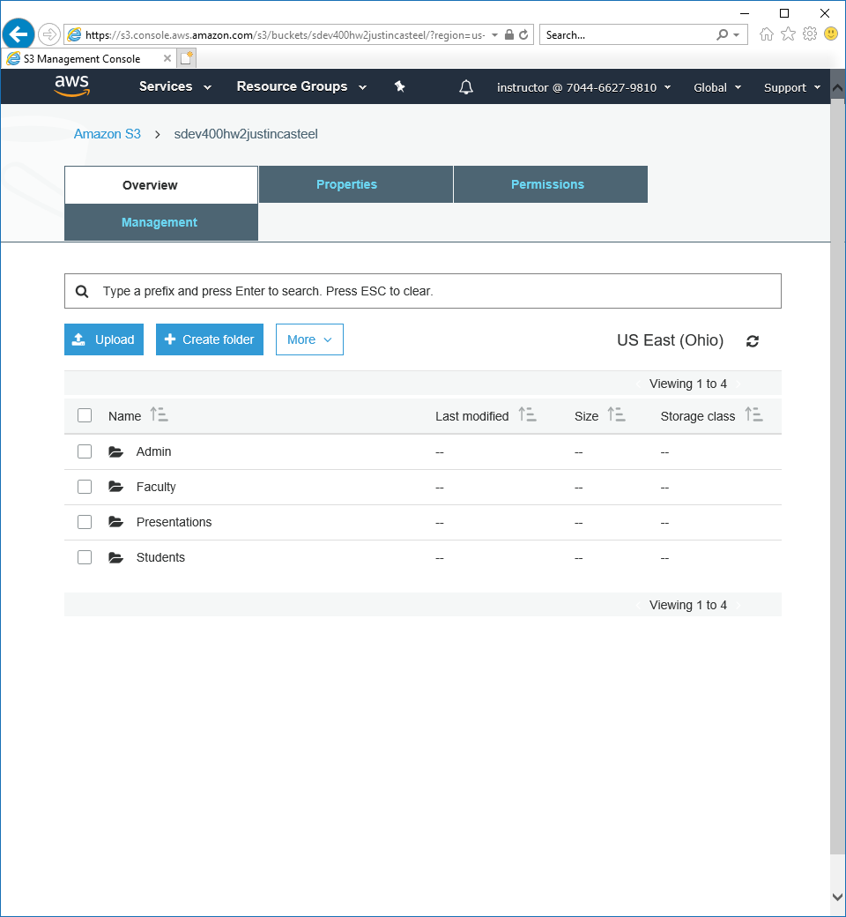

When trying to access the Students folder we receive an error.

Figure 37 - Students folder error

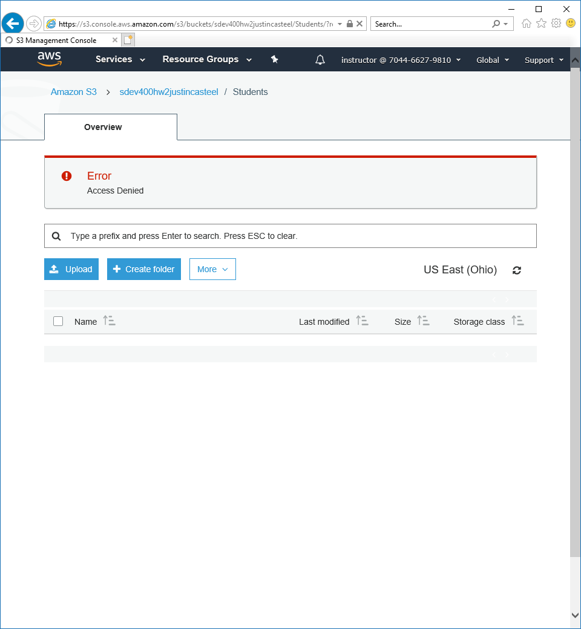

We can view, upload, and download from the Faculty folder.

Figure 38 - Faculty folder view and upload

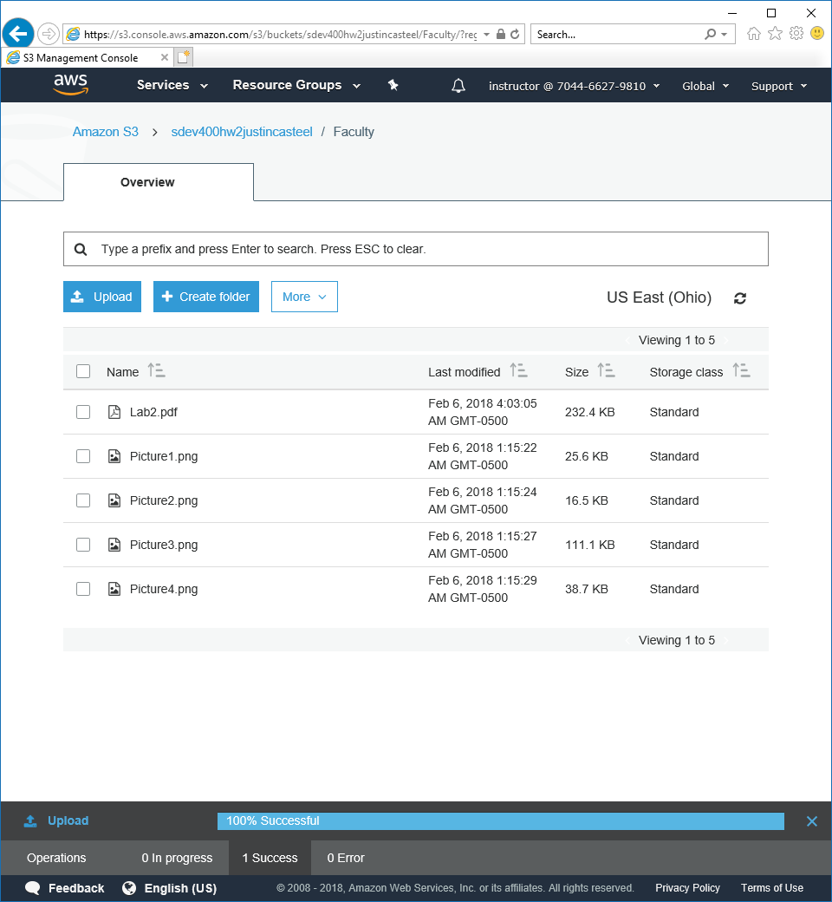

Figure 39 - Faculty folder open file

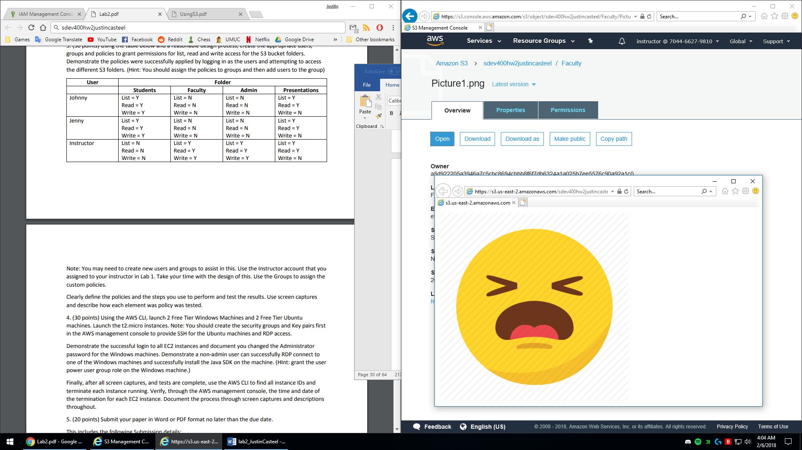

We then move to the Admin folder to test that we can upload and view files as well.

Figure 40 - Admin folder upload and view

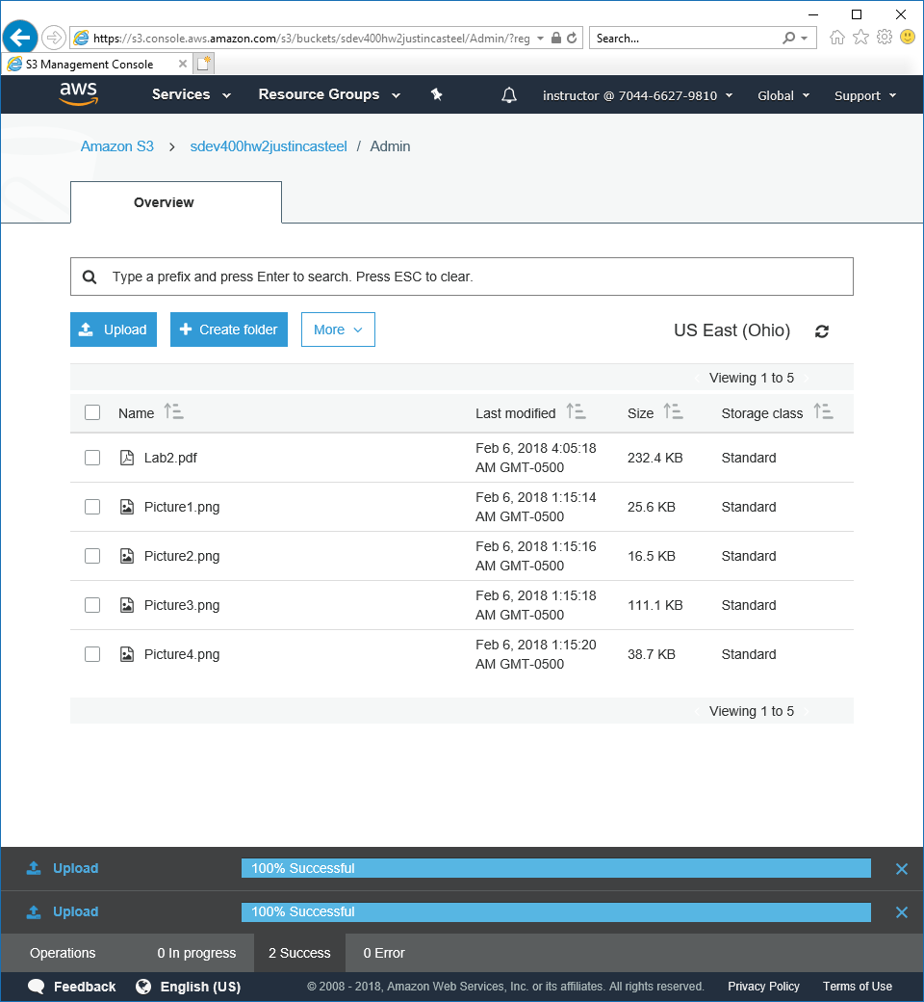

Figure 41 - File view in Admin folder

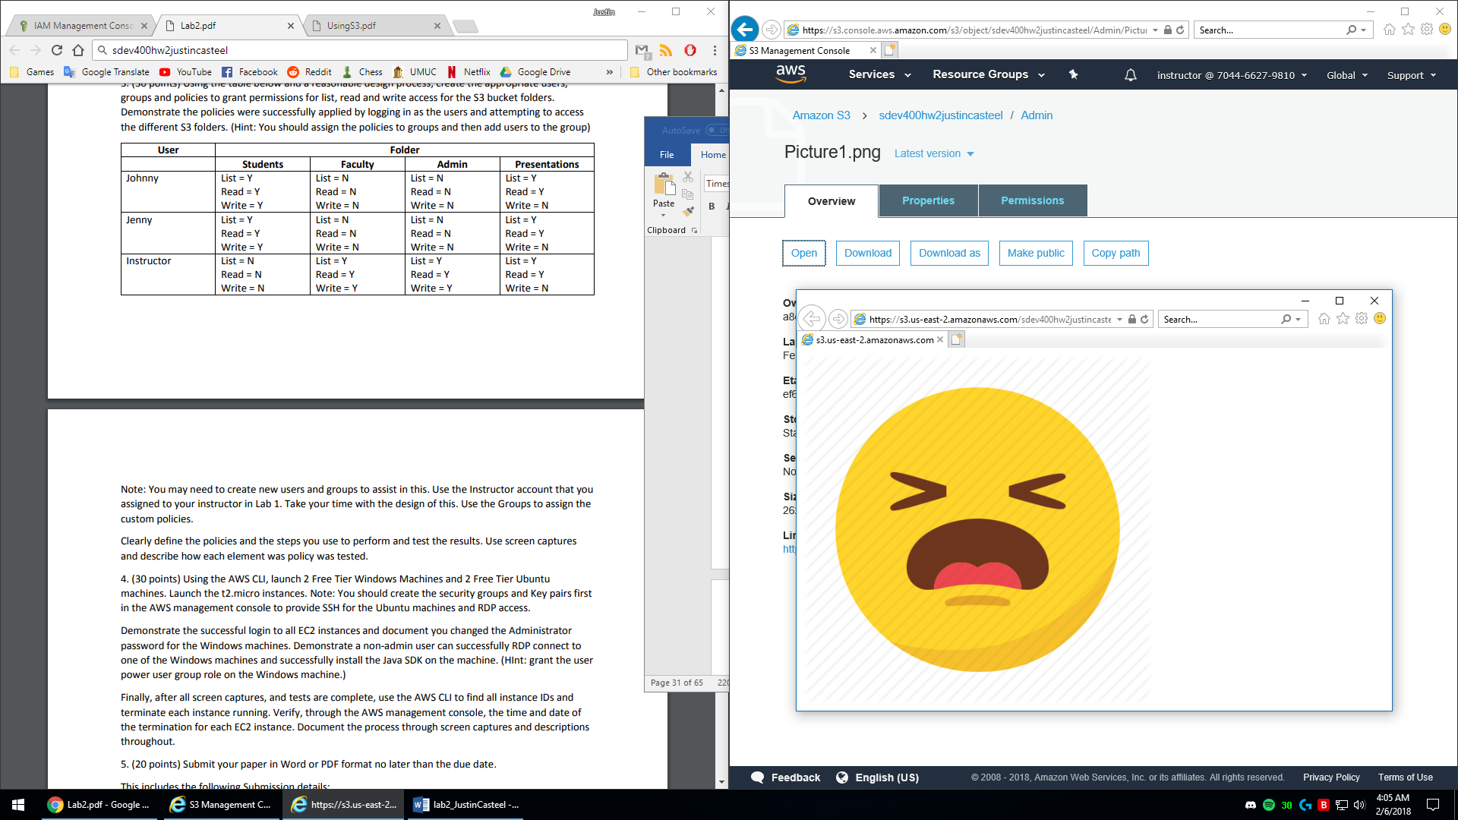

I then test that we can see and view files from the presentations folder, but per our policy we are not allowed to upload files.

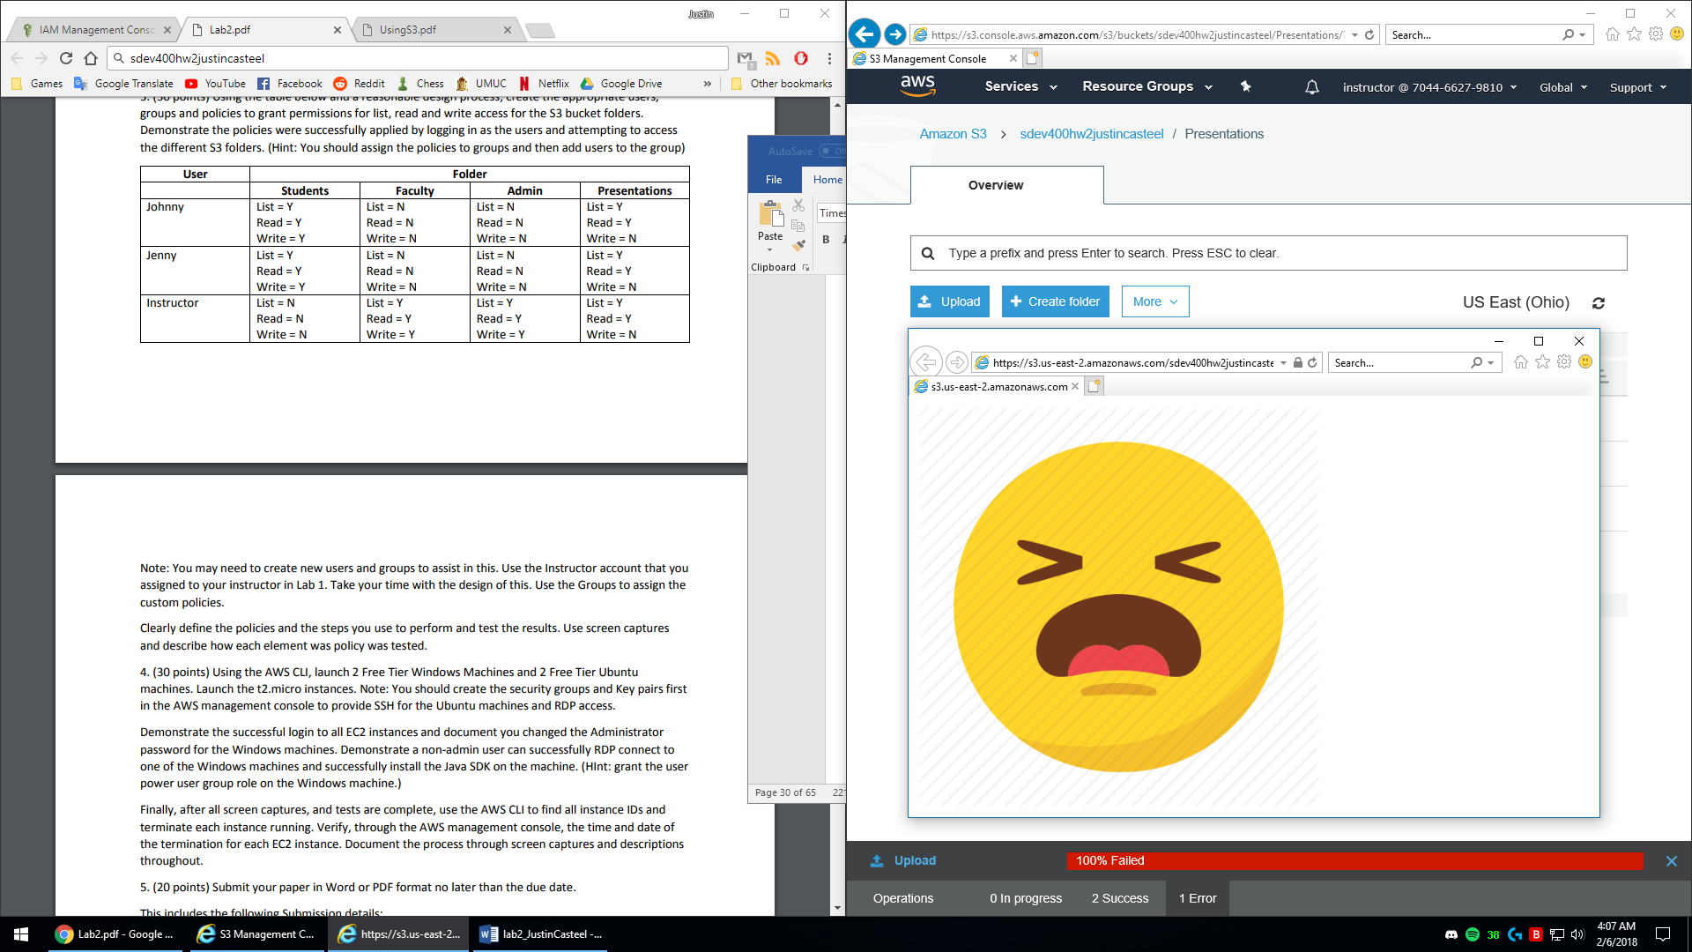

Both the instructor policies and the student policies are now fully working and will grant and block access as per our policies. This was the most challenging part of the entire lab and it took me a long time as you know to figure it out. Thank you for being patient with me on this assignment, I really appreciate that.

Step 4.

First, I created 2 Windows and 2 Ubuntu instances using the AWS CLI.

Figure 42 - Windows instance 1

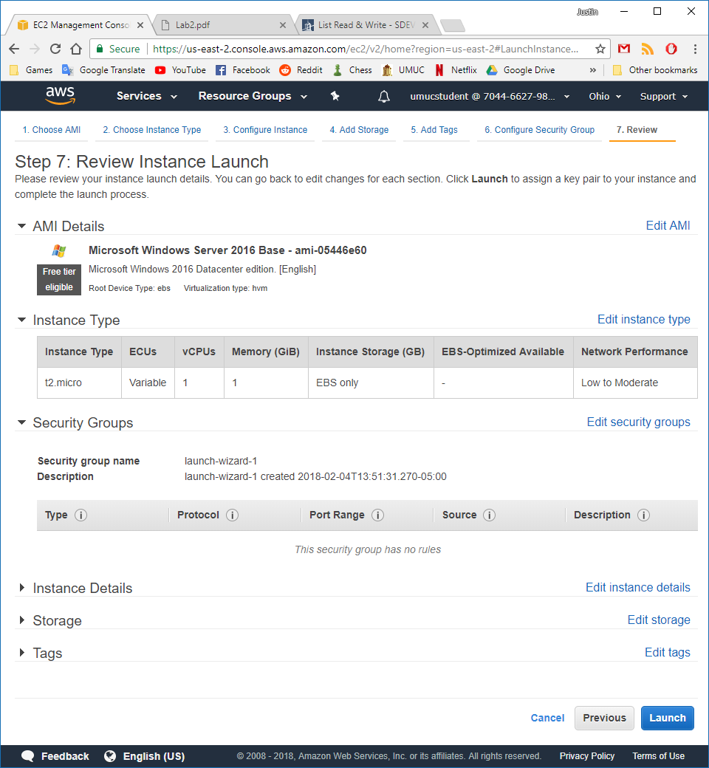

Changing the “Source” to “My IP” so outside users are not authorized on this machine which is best security practice. This limits the machine to only my IP address so only I can access it.

Figure 43 - Windows instance 1 security group

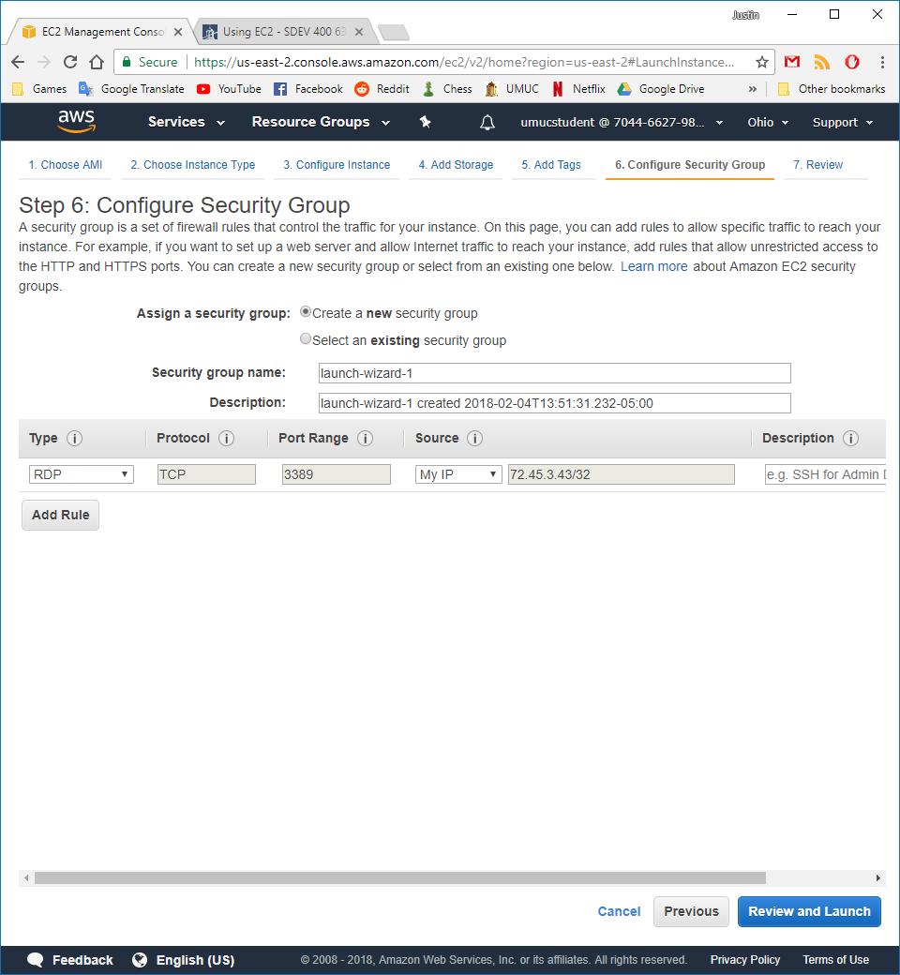

Figure 44 - Launch status

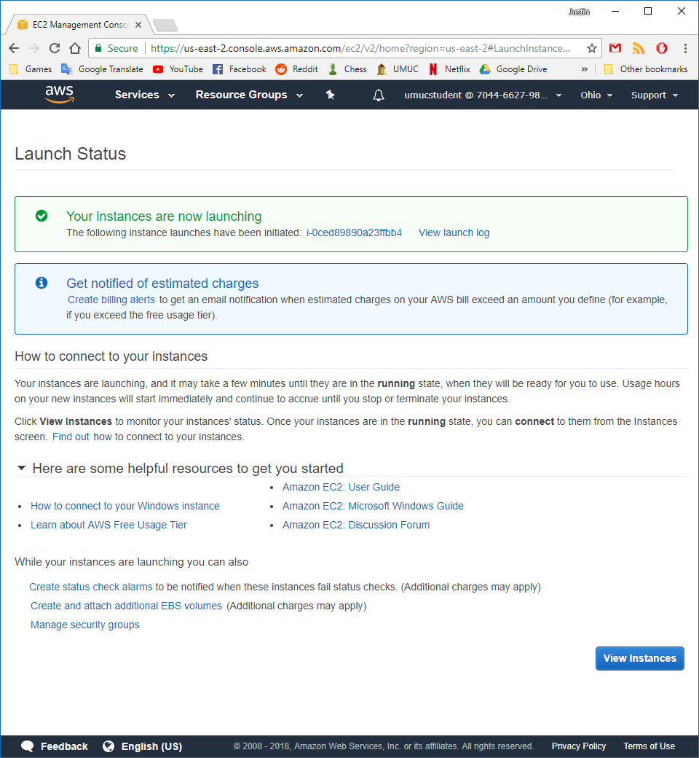

I then create a key pair that we will use to connect to the new instance remotely. In this case I have named the key pair “windows 1” and “windows 2” in my first and second windows instances.

Figure 45 - Windows Machine key pairs

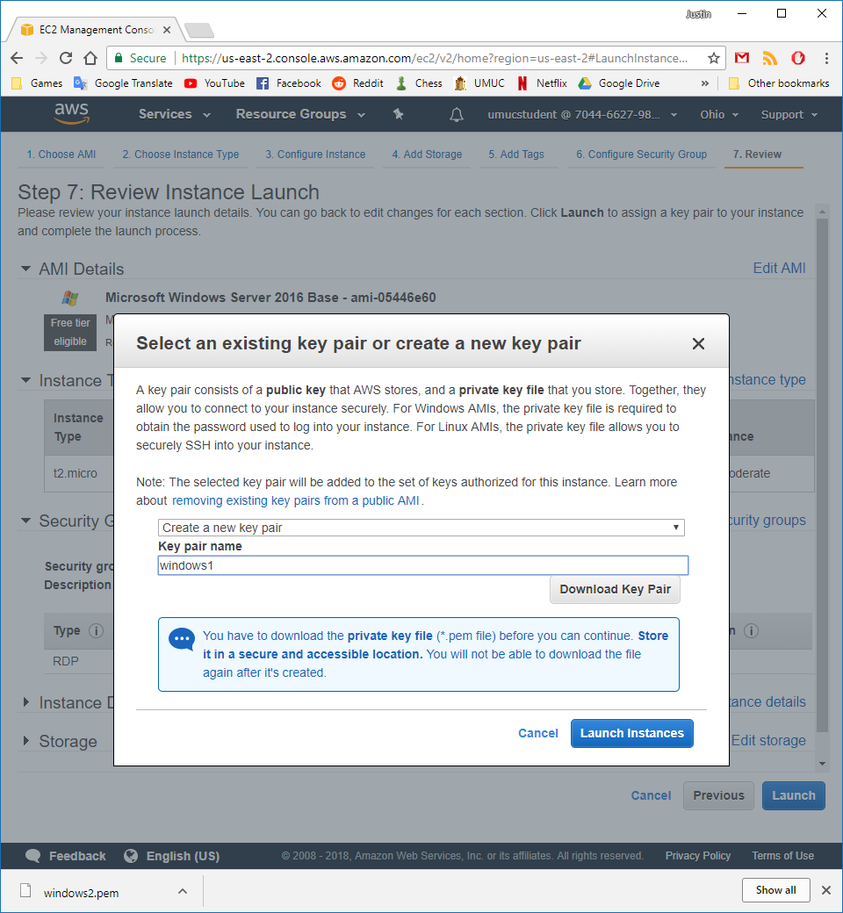

I then create 2 Ubuntu instances using the “Ubuntu Server 16.04 LTS (HVM), SSD Volume Type - ami-2581aa40” setup and change the security groups to only allow my IP address to connect through SSH. The two keys I created are called ubuntu1 and ubuntu2 for consistency with the windows servers.

Figure 46 - Ubuntu instance setup and review

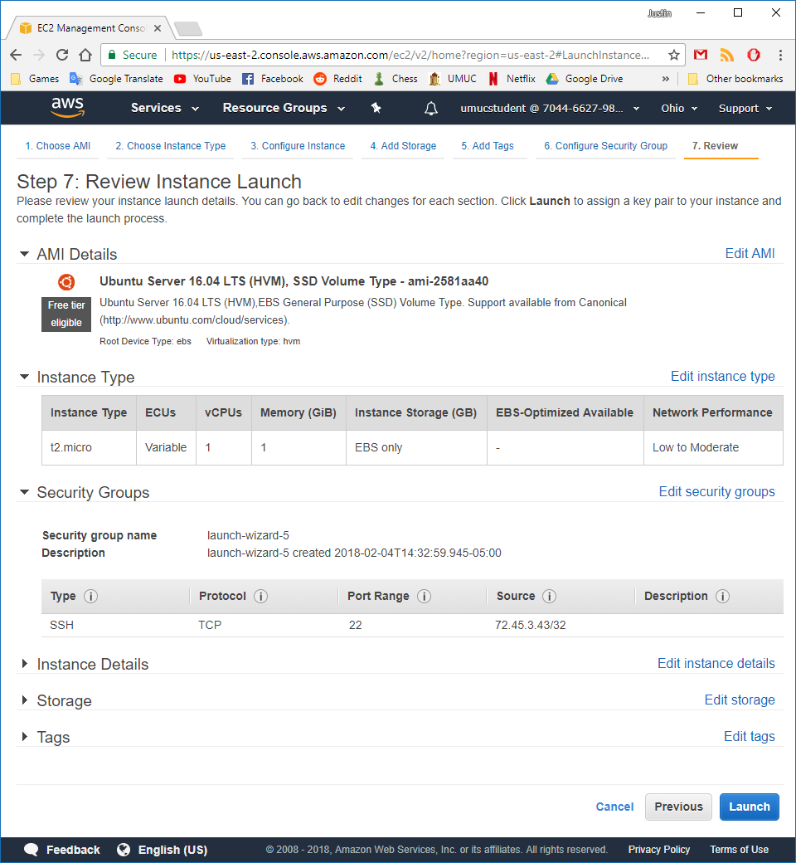

To keep my instances organized I provided named for each instance. Ubuntu 1/2 and Windows 1/2 as shown in figure 17.

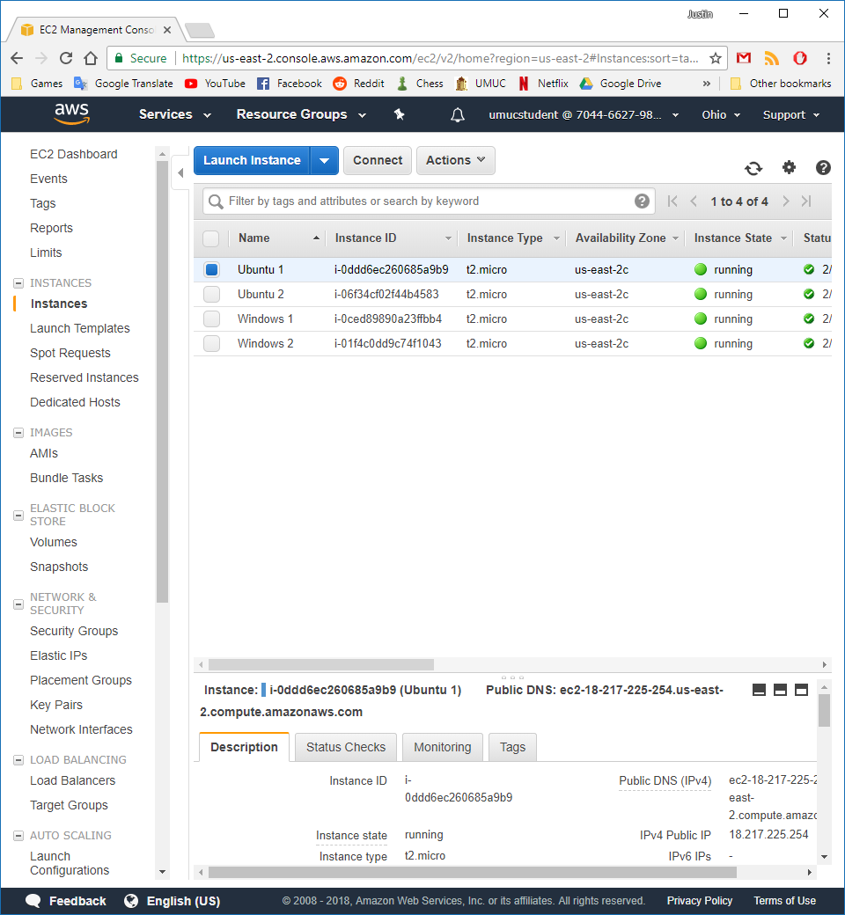

I now connect to the Windows 1 instance, but first use the key pair file that I created earlier. I navigate to the desktop and find the file and then click decrypt password, which results in the following:

Figure 47 - Connect Windows 1 instance

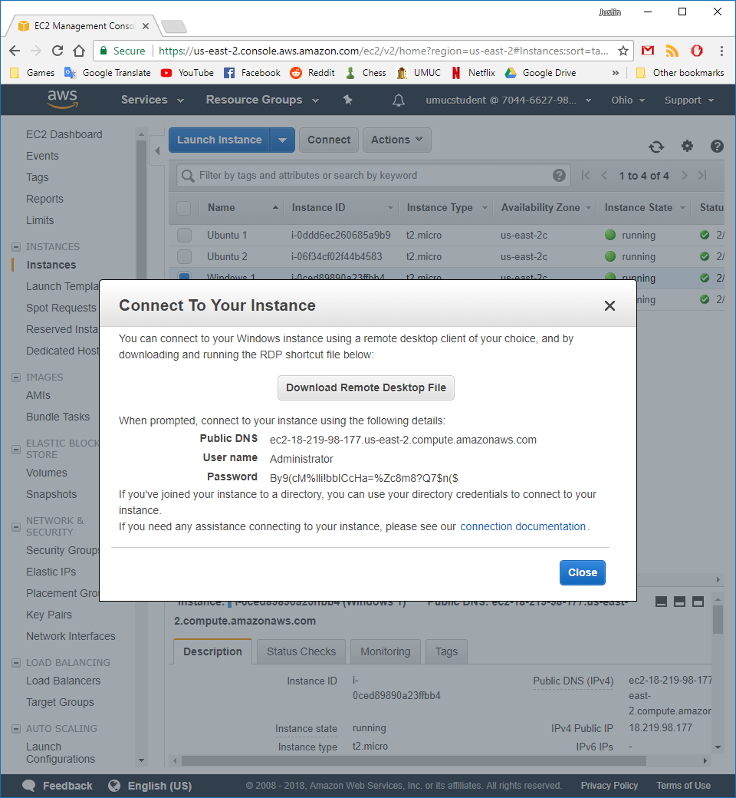

I then open the Remote Desktop Connection application on my Windows machine to connect to all 4 remote servers.

Figure 48 – Windows instance 1 remote

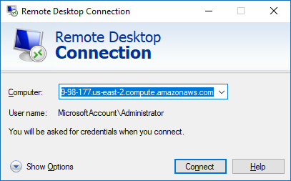

Figure 49 - Windows instance 1

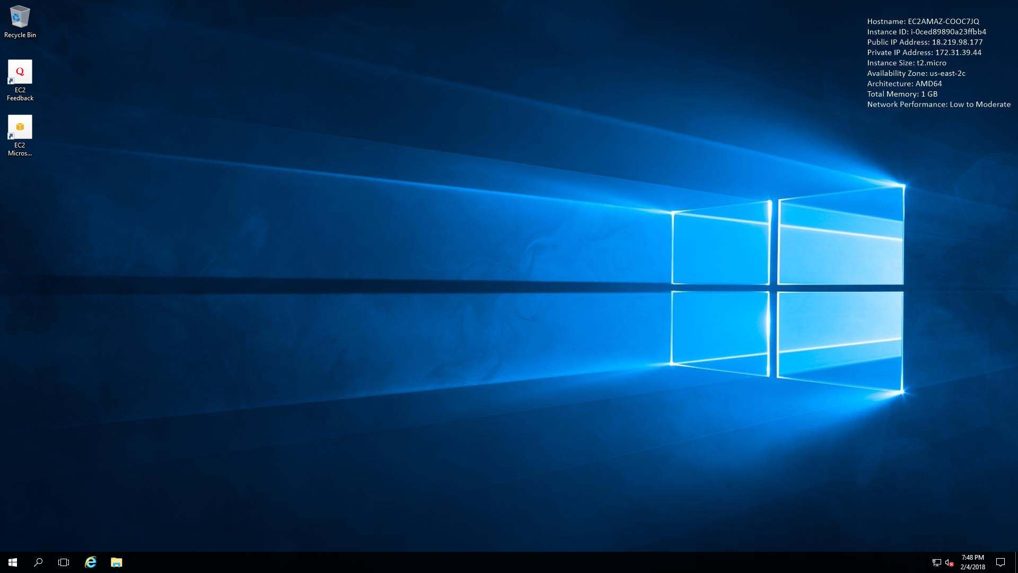

I then go into the account sign in options on the remote machines and change both passwords.

Figure 50 - Windows instance 1 password change

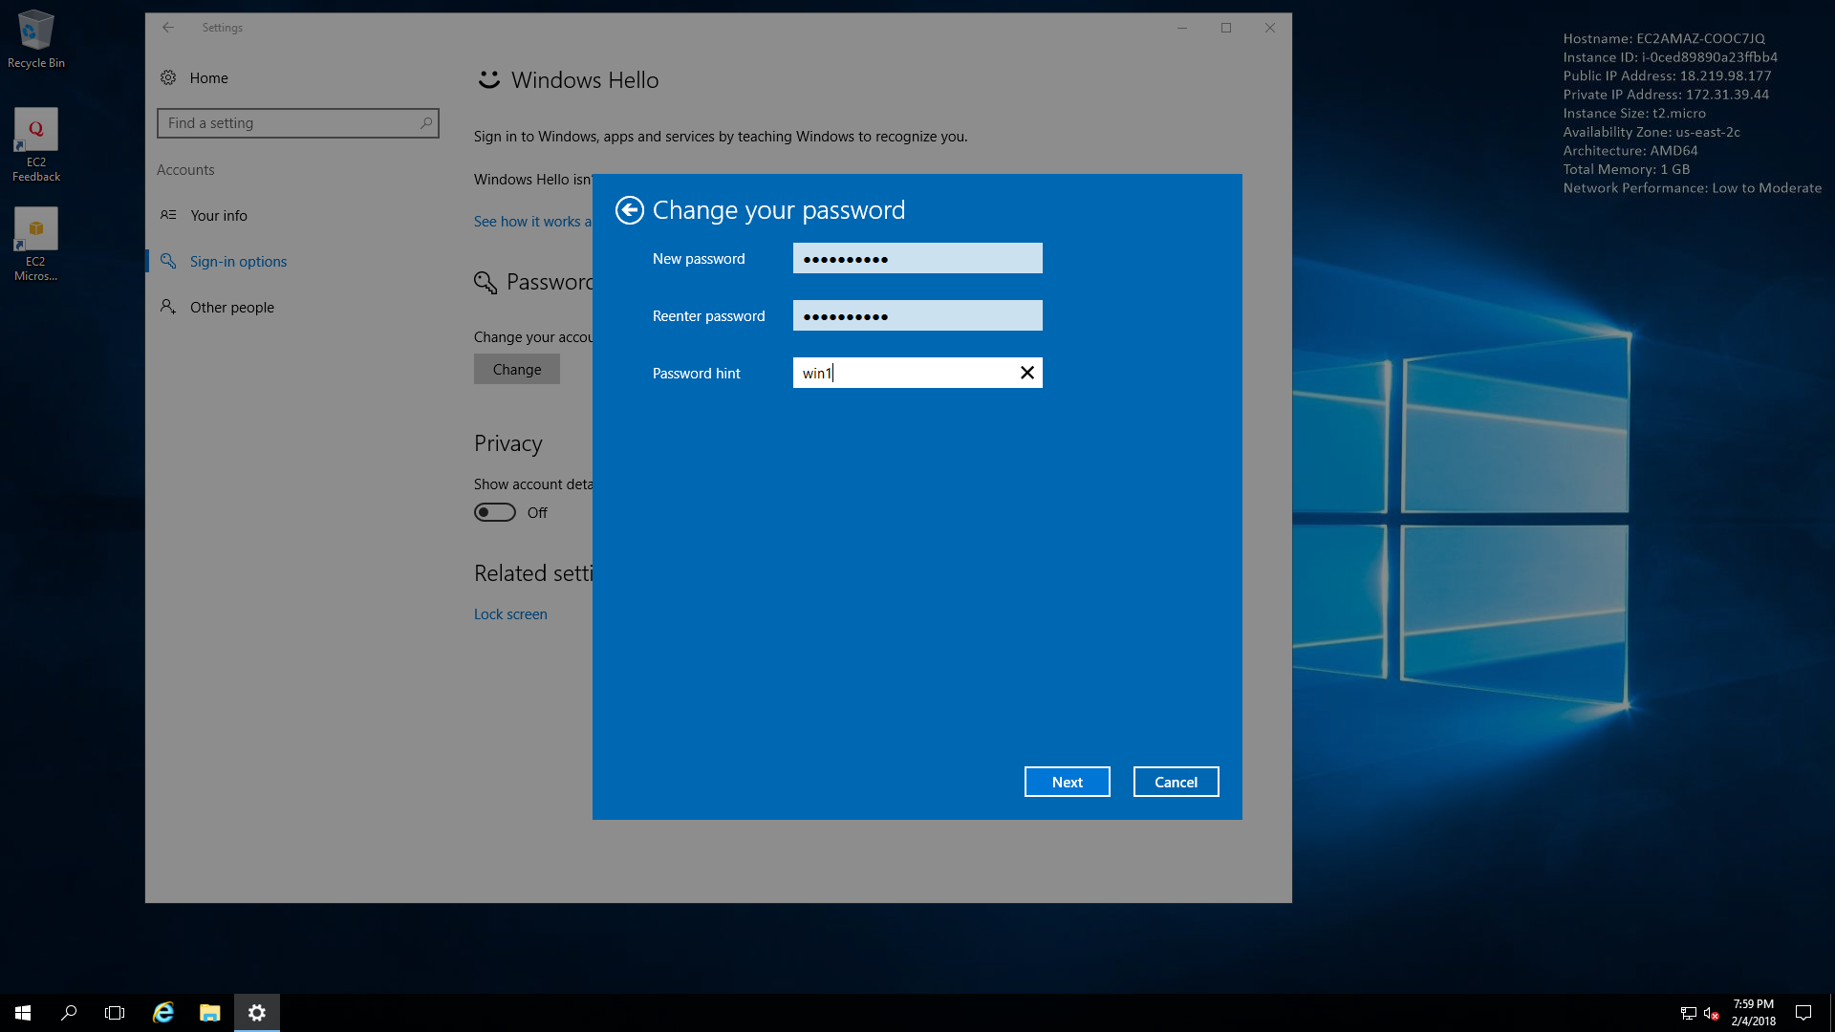

Figure 51 - Windows instance 2 password change

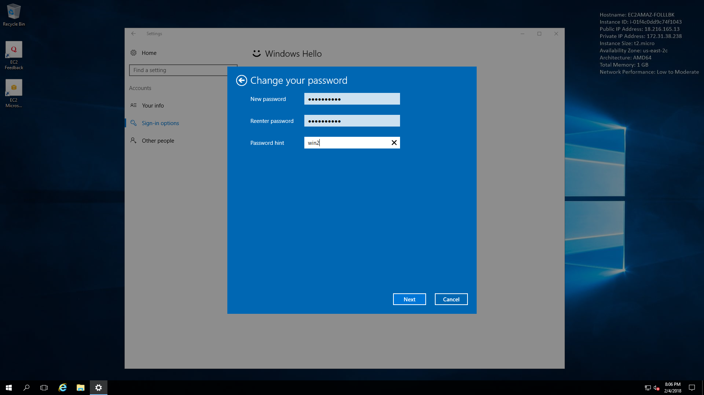

I can now log in using the new passwords that I have created for both windows instances.

Figure 52 - Windows instance 2 login with new passowrd

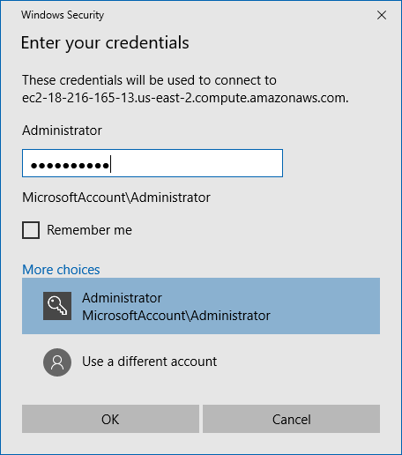

Figure 53- Windows instance 1 login with new password

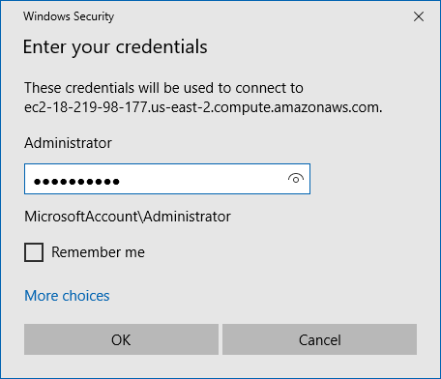

Figure 54 - Windows instance 2 remote

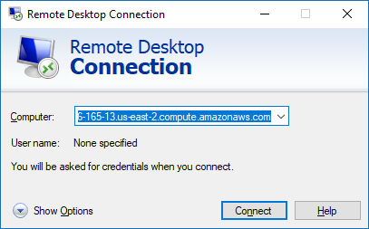

Figure 55 - Windows instance 2

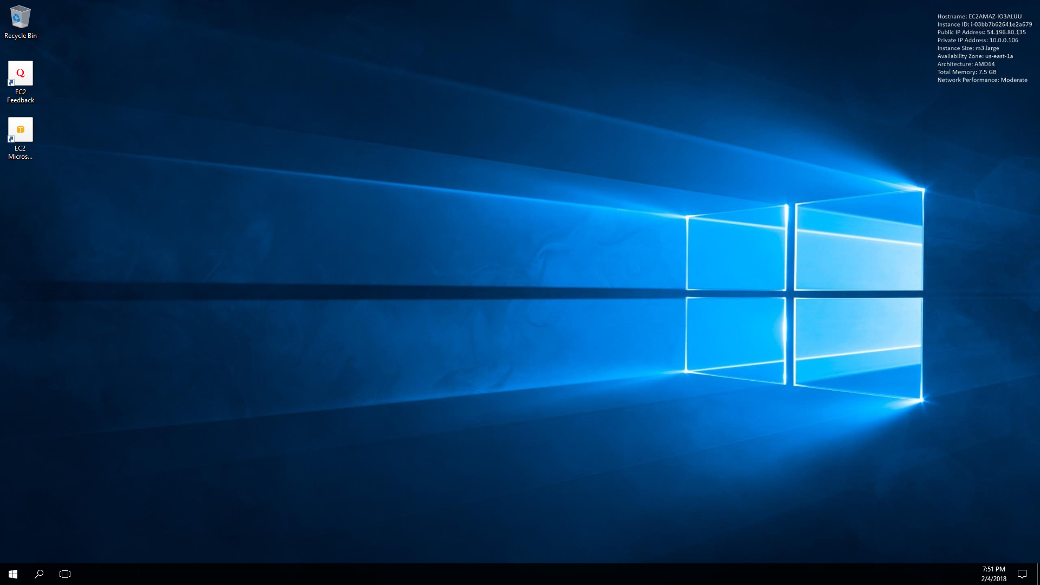

I then create a new non-root user account to provide details to someone to remotely connect to my new instances. This will provide them access to the server but not full access.

Figure 56 - New non-root user created

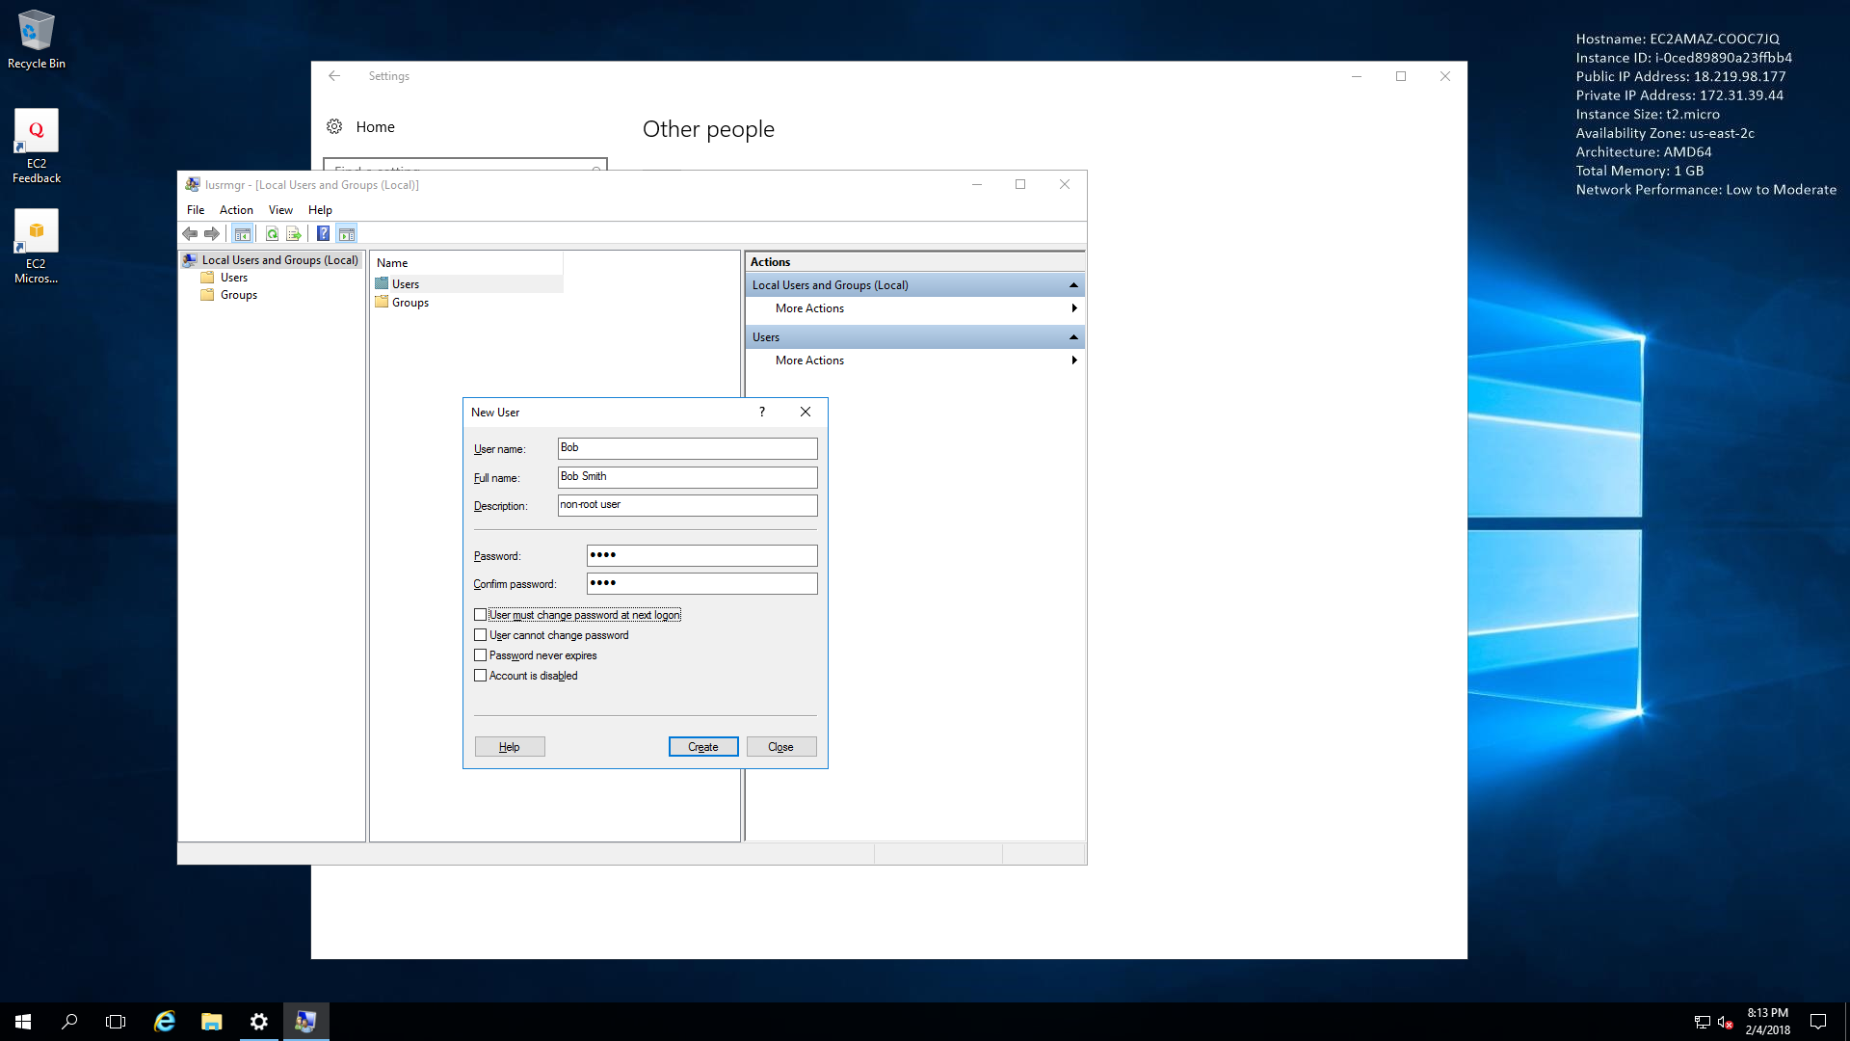

I then add our new user Bob to the remote desktop users group and the power users group.

Figure 57 - Remote desktop users group

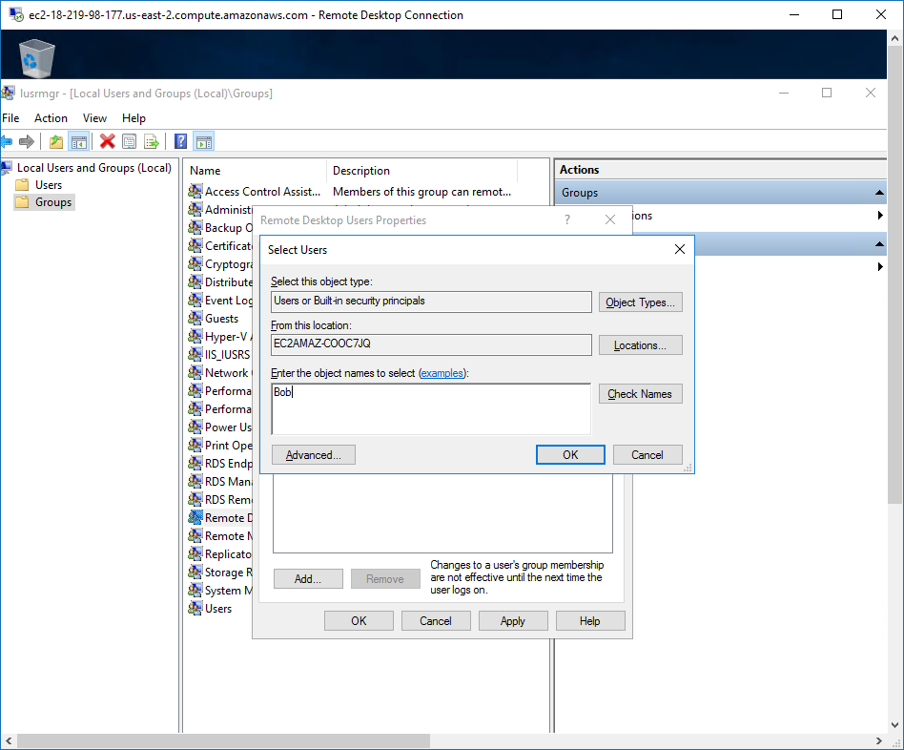

Figure 58 - Remote desktop user properties

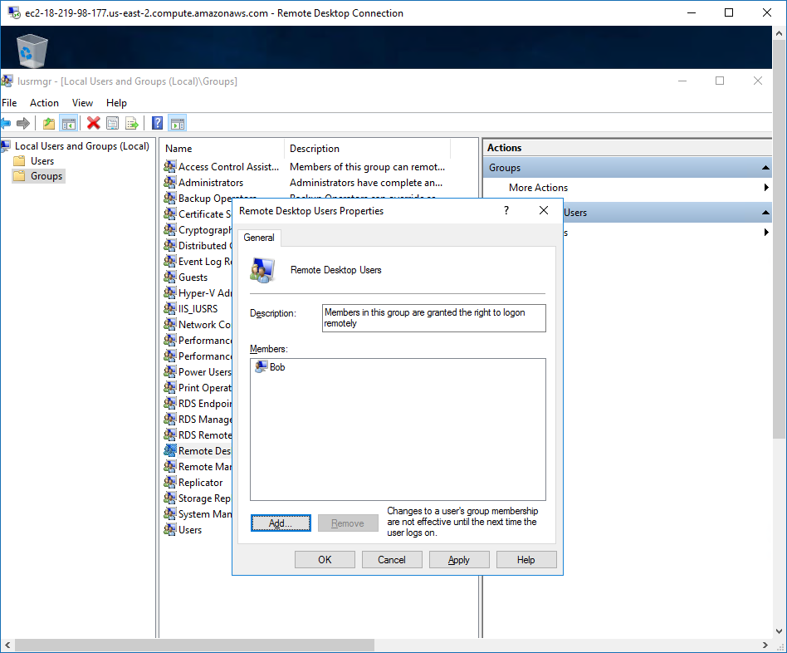

Figure 59 - Power users group

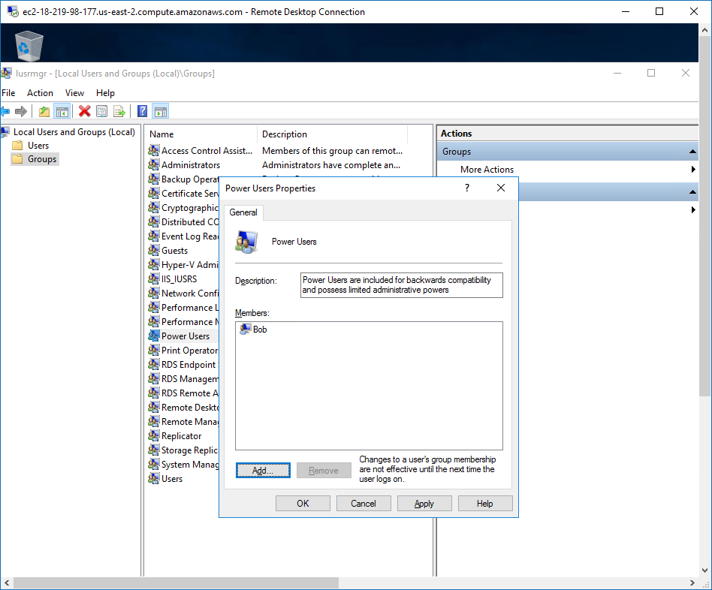

Figure 60 - Logging in with non-root user Bob

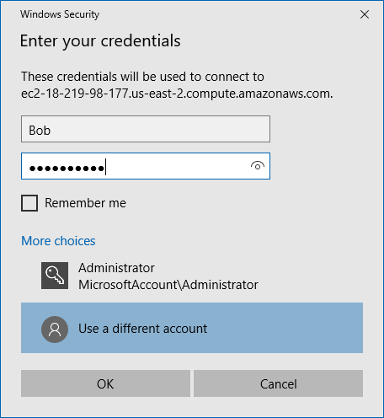

In figure 31 you can see that Bob Smith can successfully log in through remote desktop and perform the duties that we have given him.

Figure 61 - Bob Smith logged in

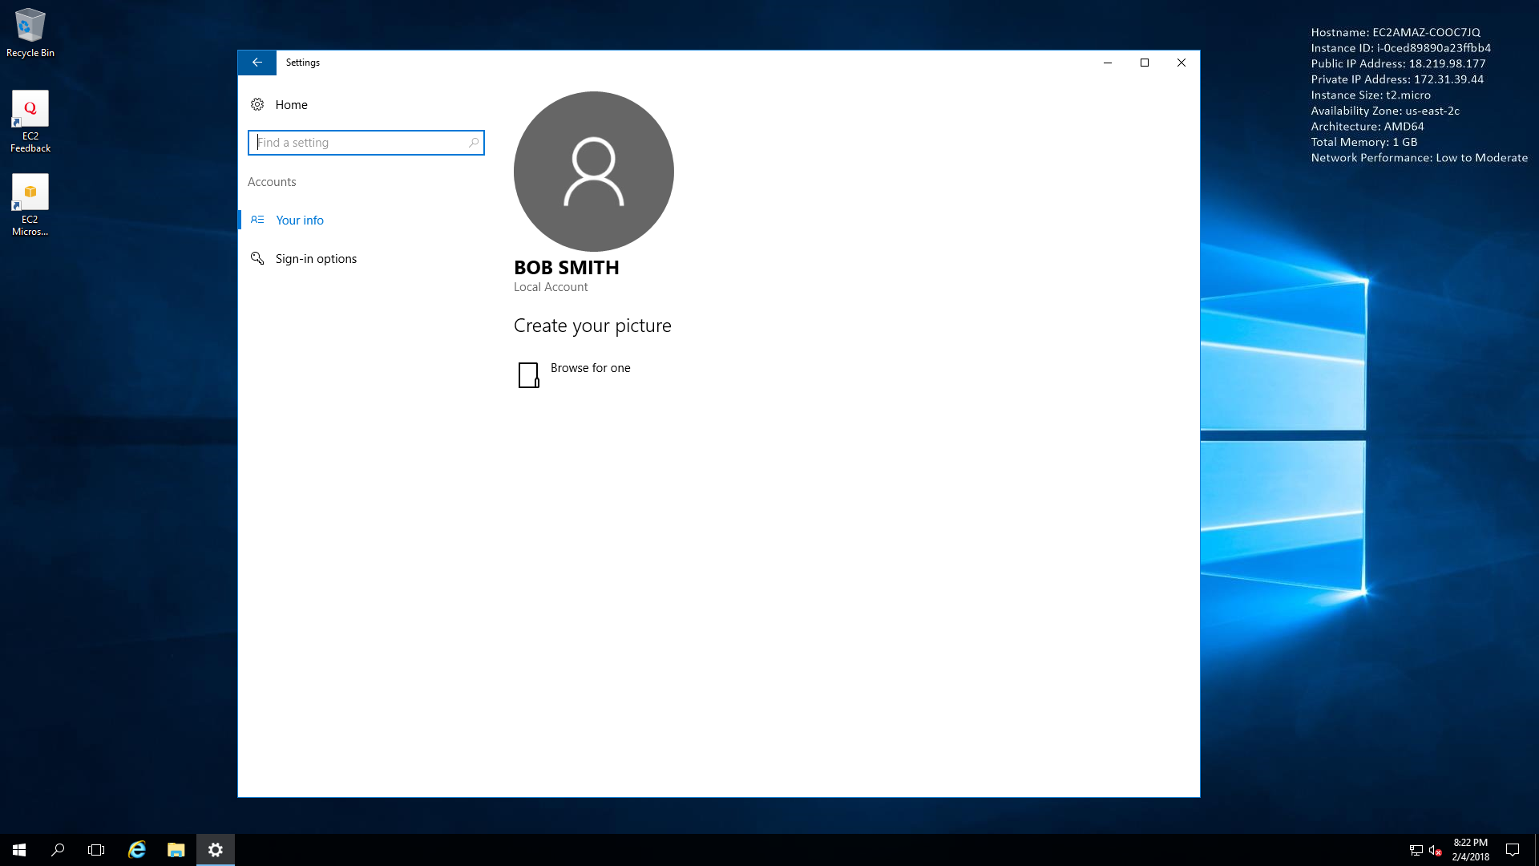

I click start and then choose to disconnect because in some cases the user may be stuck in the instance and unable to log back in for some time. It is best practice to disconnect from the instance when finished.

Figure 62 - Bob Smith Disconnect

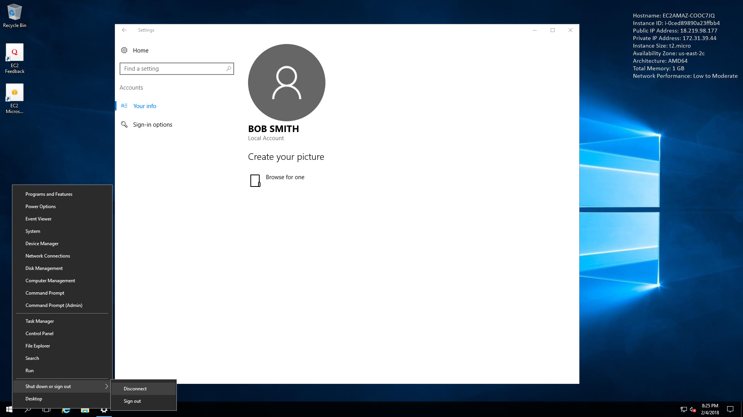

When trying to even download the SDK java package to try and install it I was running into issues. The AWS instance machines have a security feature on their browser, so you are unable to download anything at all, so I couldn’t test installing SDK. Here’s a screenshot of what I see when trying to download the package, this is on the administrator account as well. I did try with the Bob account first and had the same issue. UPDATE: I had to disable the Internet Explorer Enhanced Security Configuration, shown below. But when disabling this on the Admin account for all accounts on the server it still didn’t disable it for my non-root account Bob but it says that it IS disabled. Figure 34 shows this.

Figure 63- Internet Explorer Enhanced Security Configuration – Admin account

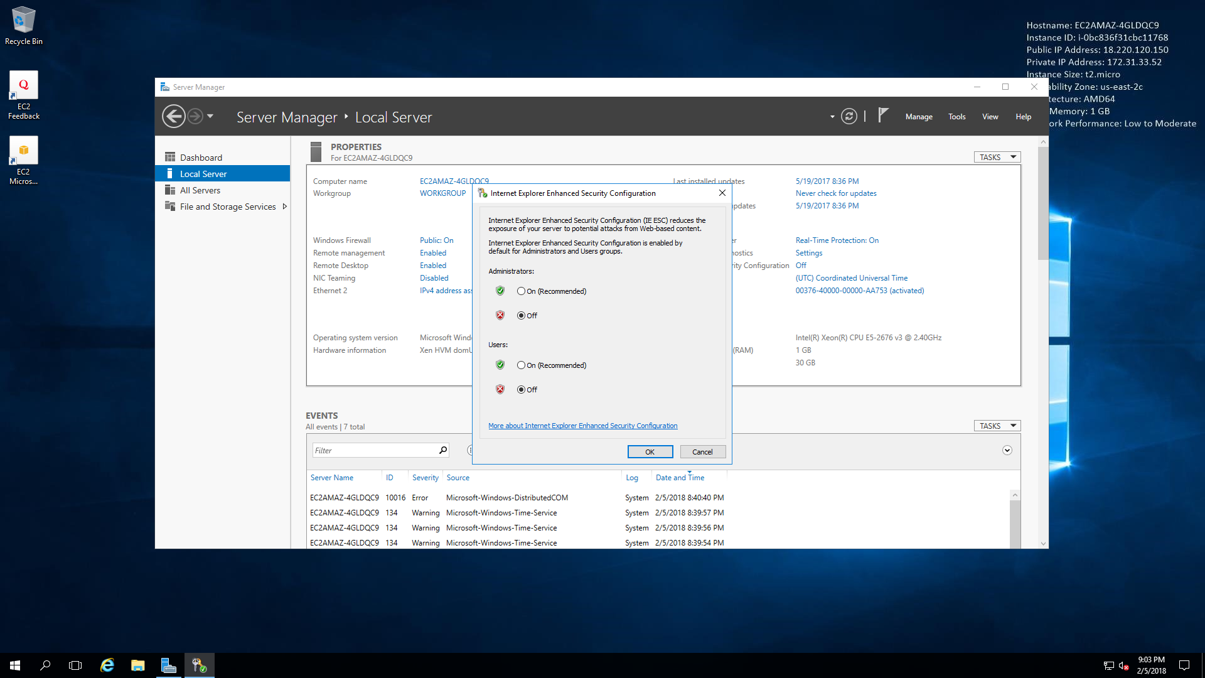

Figure 64 - Internet Explorer Enhanced Security Configuration - Bob Account

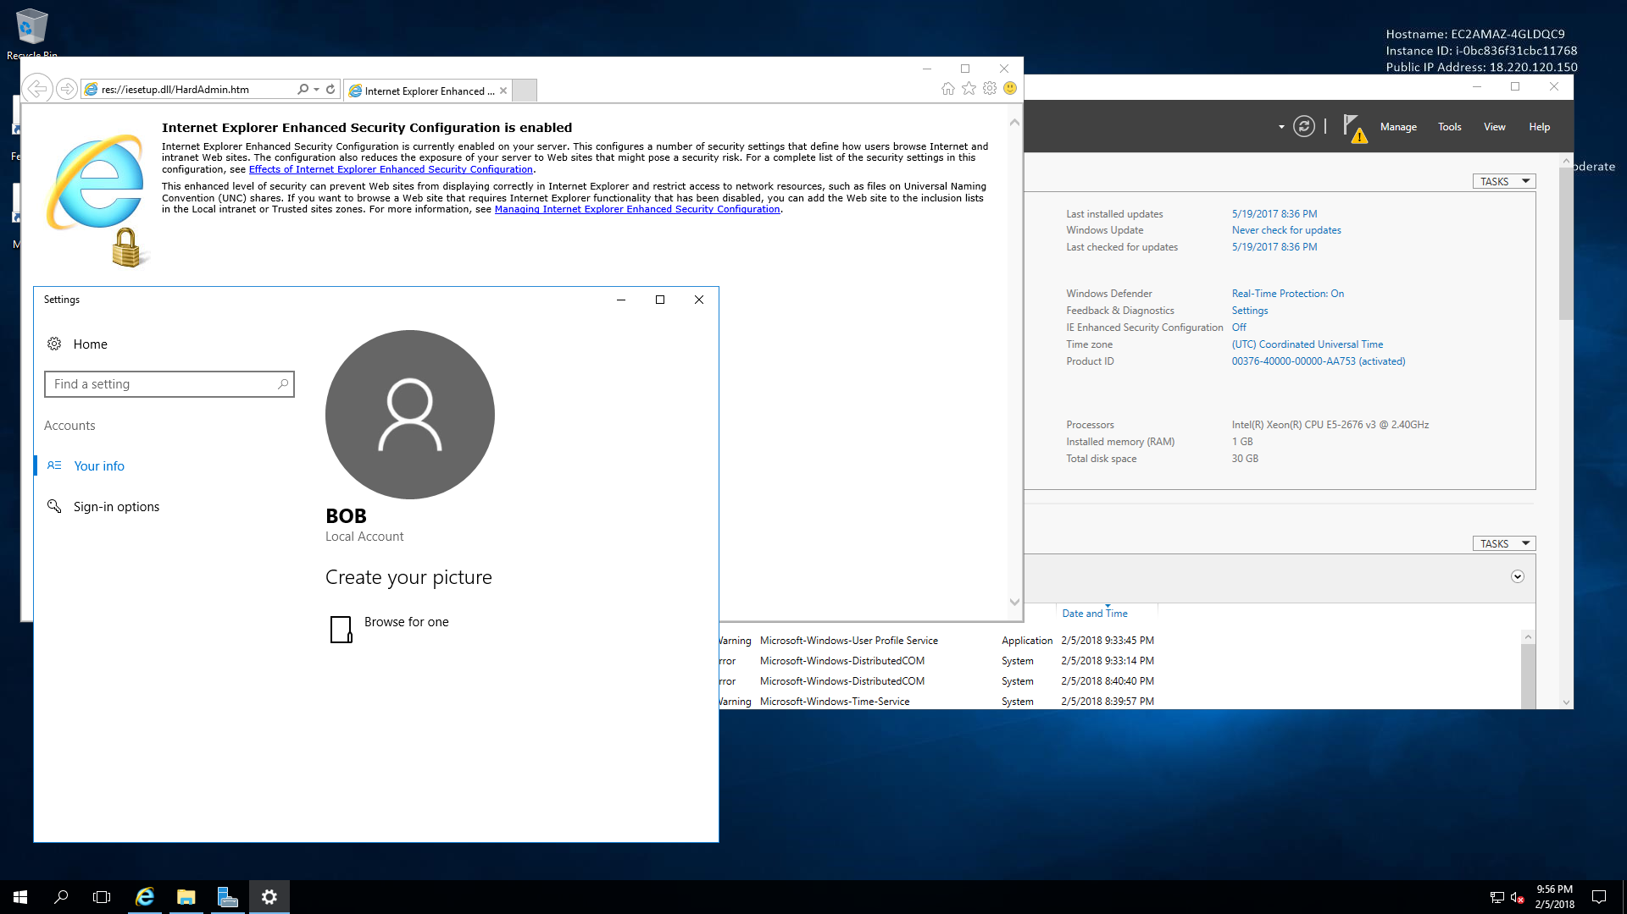

z

Figure 65 - Java SDK download page – Admin account

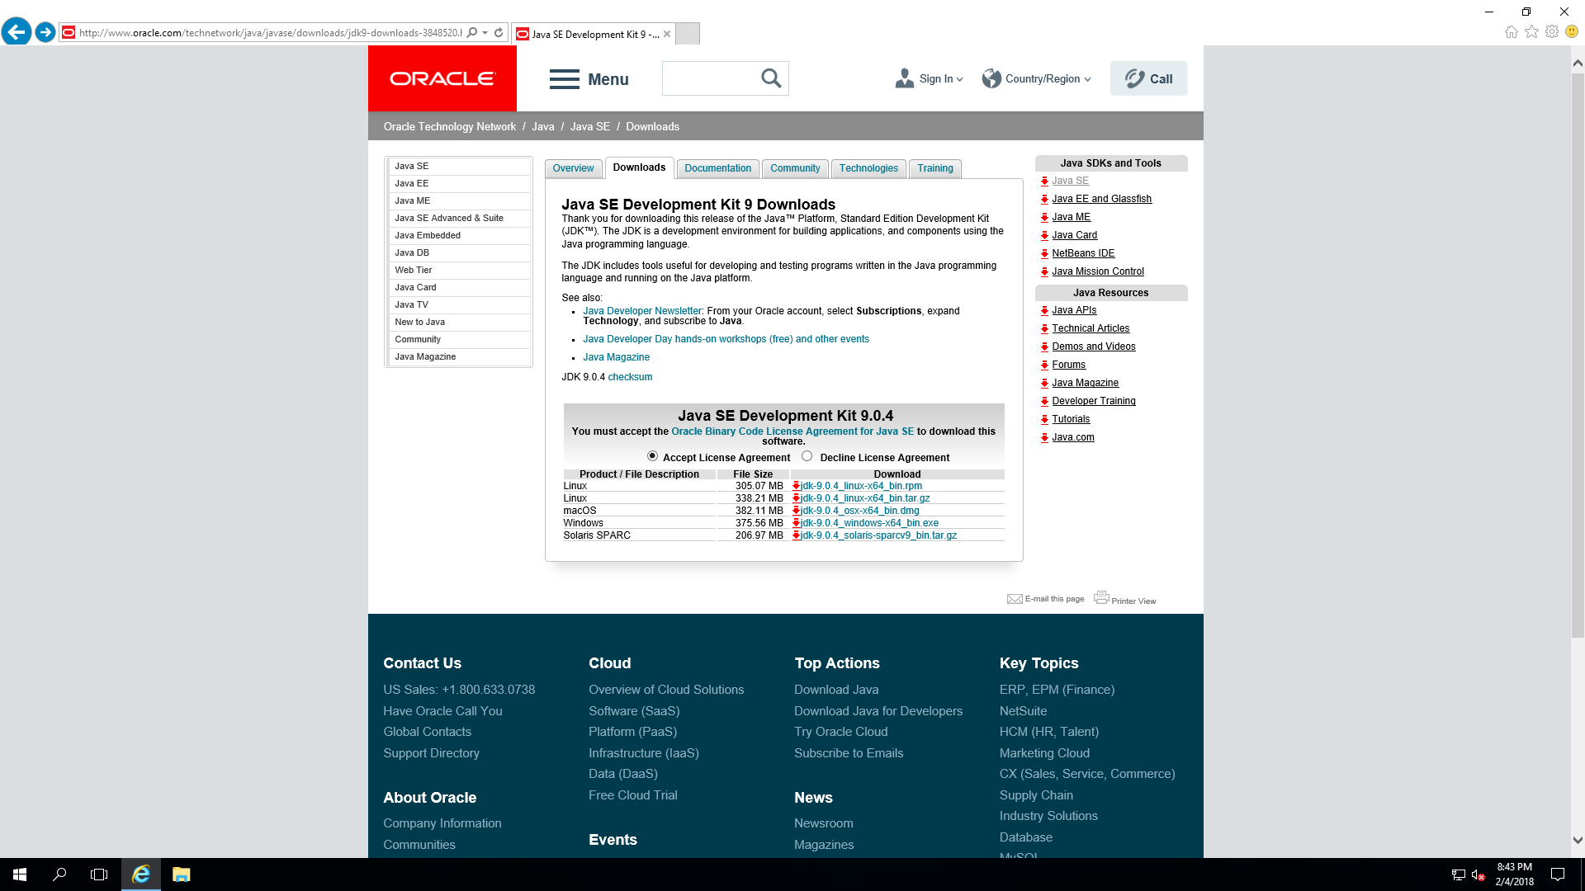

Figure 66 - Java install - Admin account

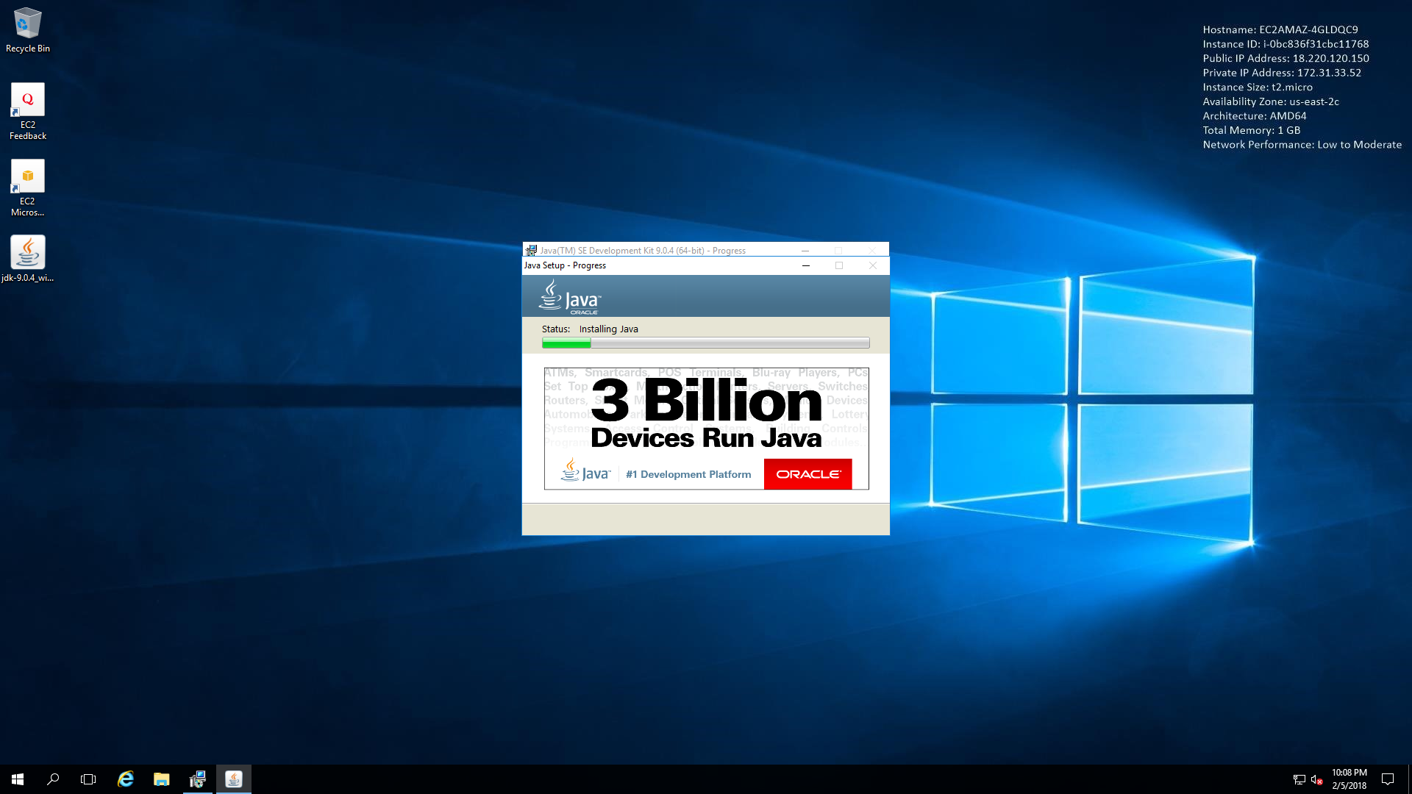

I went ahead and installed Java SDK on my admin account just to show that I can download and install java, it just wouldn’t let me do it on the non-root account because of IE settings that I tried disabling.

Figure 67 - Java install success - Admin account

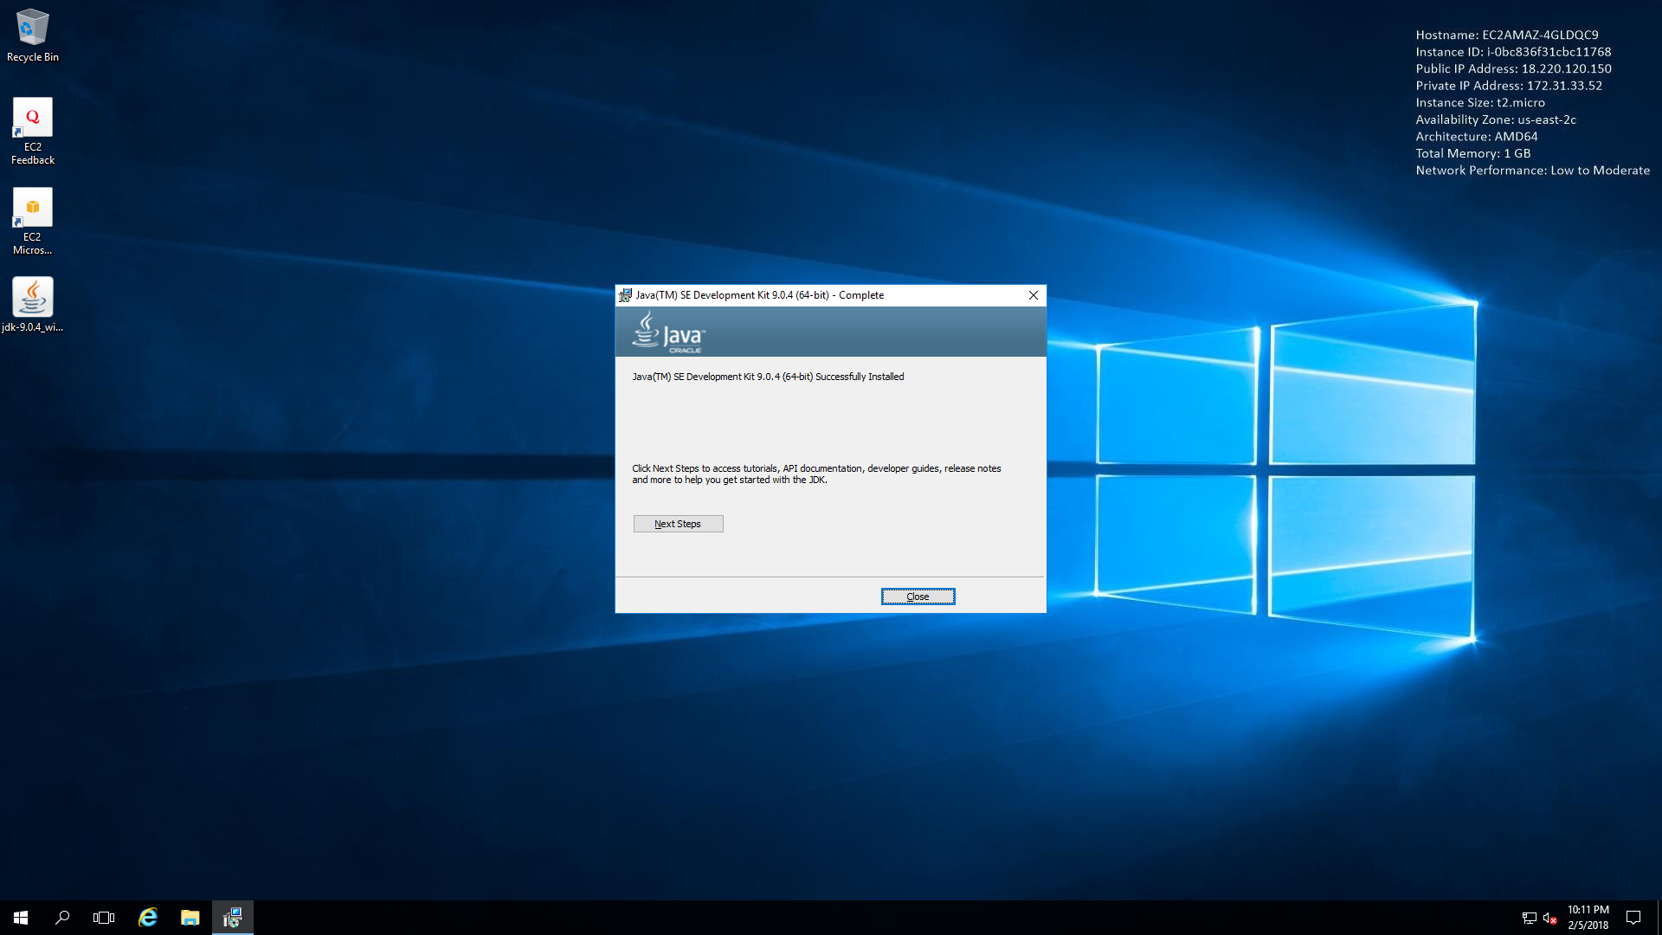

Now I connect to each of my Ubuntu instances. I chose to use putty in my case.

Figure 68 - Ubuntu instance 1

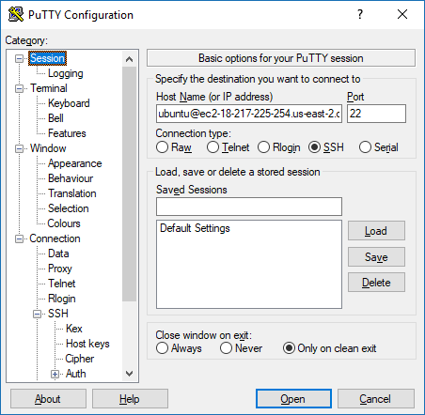

I now connect to both ubuntu instances as shown below. I have used puttygen to create my key files from the files that were created with the instances.

Figure 69 - Connected to both ubuntu instances

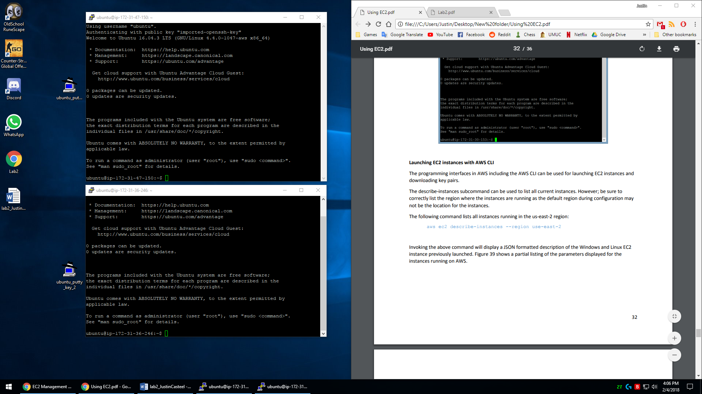

I then open the command prompt and use the following command to show all instances that are currently running on my AWS account.

aws ec2 describe-instances --region us-east-2

Figure 70 - instance command

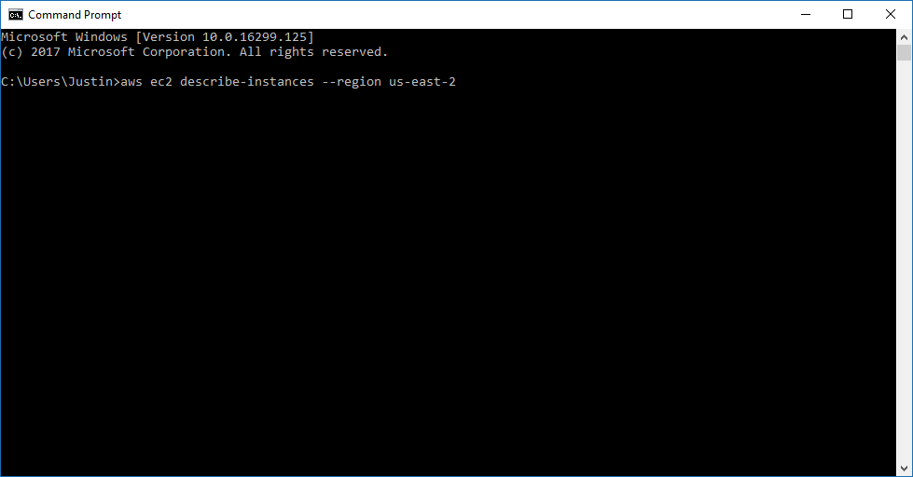

Next, I find all the instance ID’s that show from the command I have just entered.

Figure 71 - Instance ID #1 i-0ddd6ec260685a9b9

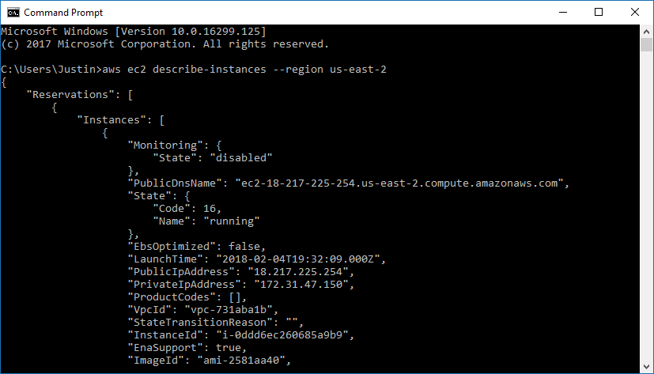

Figure 72 - Instance ID #2 i-0ced89890a23ffbb4

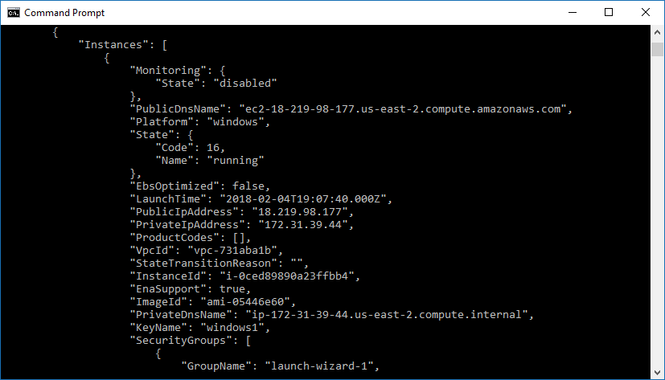

Figure 73 - Instance ID #3 i-06f34cf02f44b4583

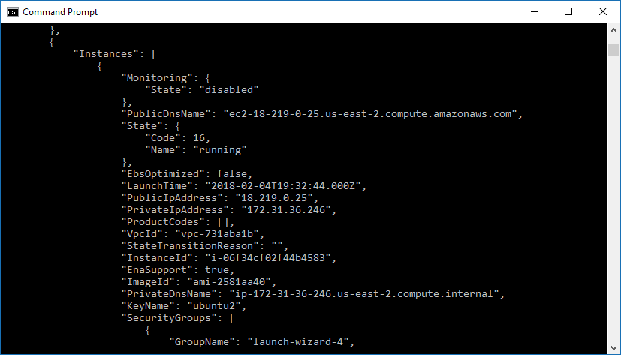

Figure 74 - Instance ID #4 i-01f4c0dd9c74f1043

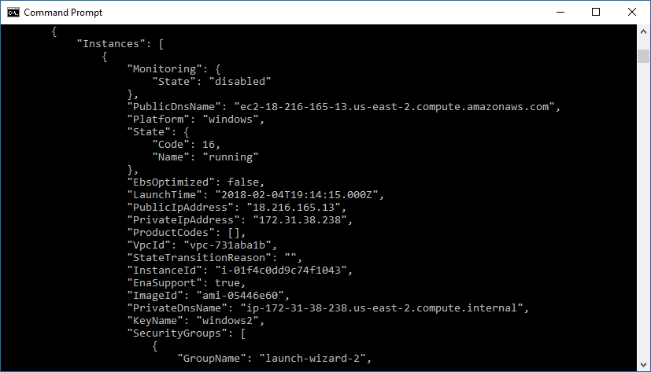

I next use the instance ID to terminate each of my instances by using the following commands:

aws ec2 terminate-instances --instance-ids i-0ddd6ec260685a9b9 --region us-east-2

aws ec2 terminate-instances --instance-ids i-0ced89890a23ffbb4 --region us-east-2

aws ec2 terminate-instances --instance-ids i-06f34cf02f44b4583 --region us-east-2

aws ec2 terminate-instances --instance-ids i-01f4c0dd9c74f1043 --region us-east-2

Figure 75 - terminate instance 1

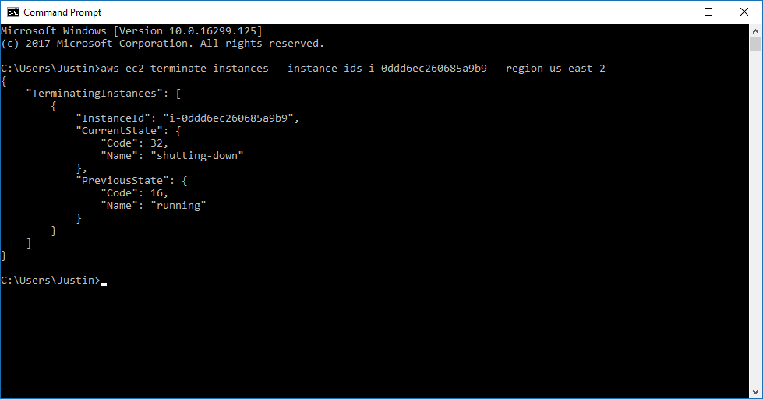

Figure 76 - terminate instance 2

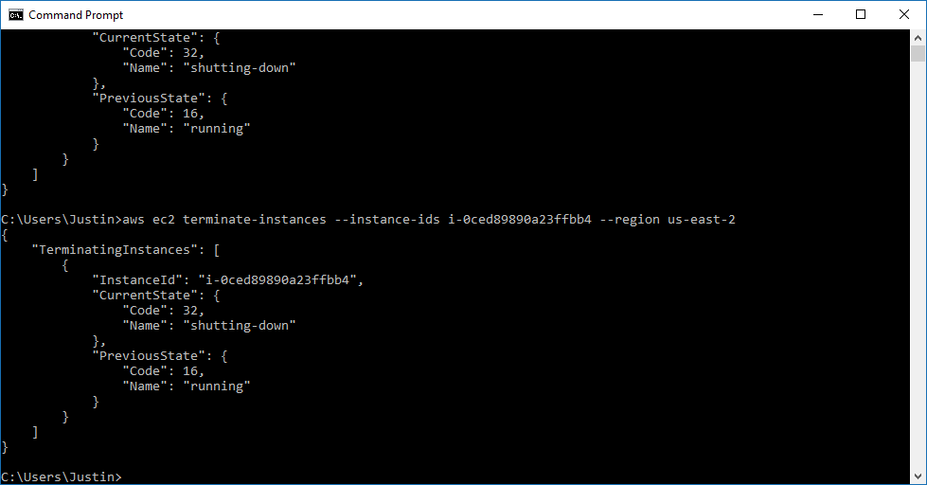

Figure 77 - terminate instance 3

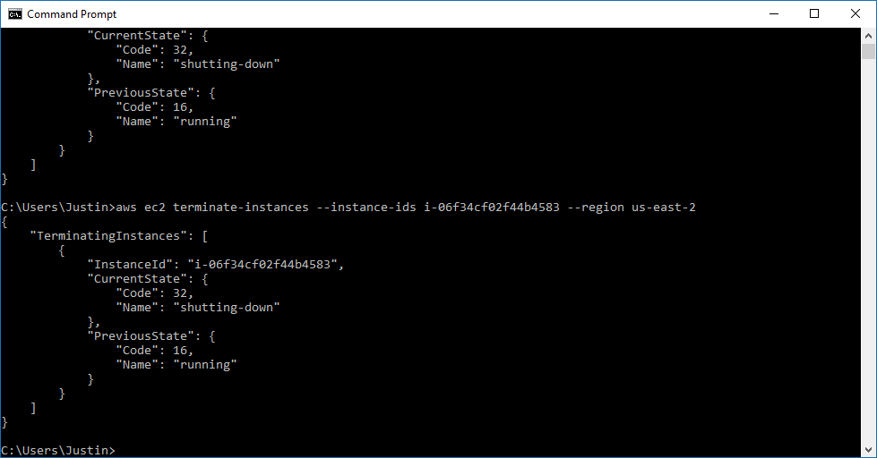

Figure 78 - terminate instance 4

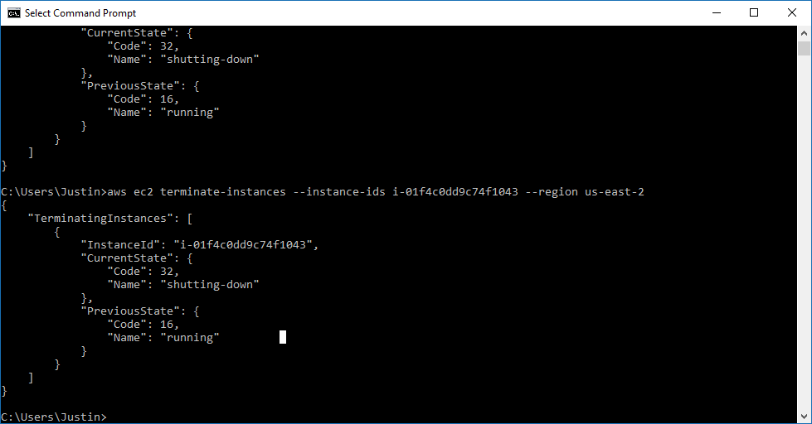

I now use the AWS Console to show the time and date that each instance was terminated.

Figure 79 - Ubuntu1 terminated instance

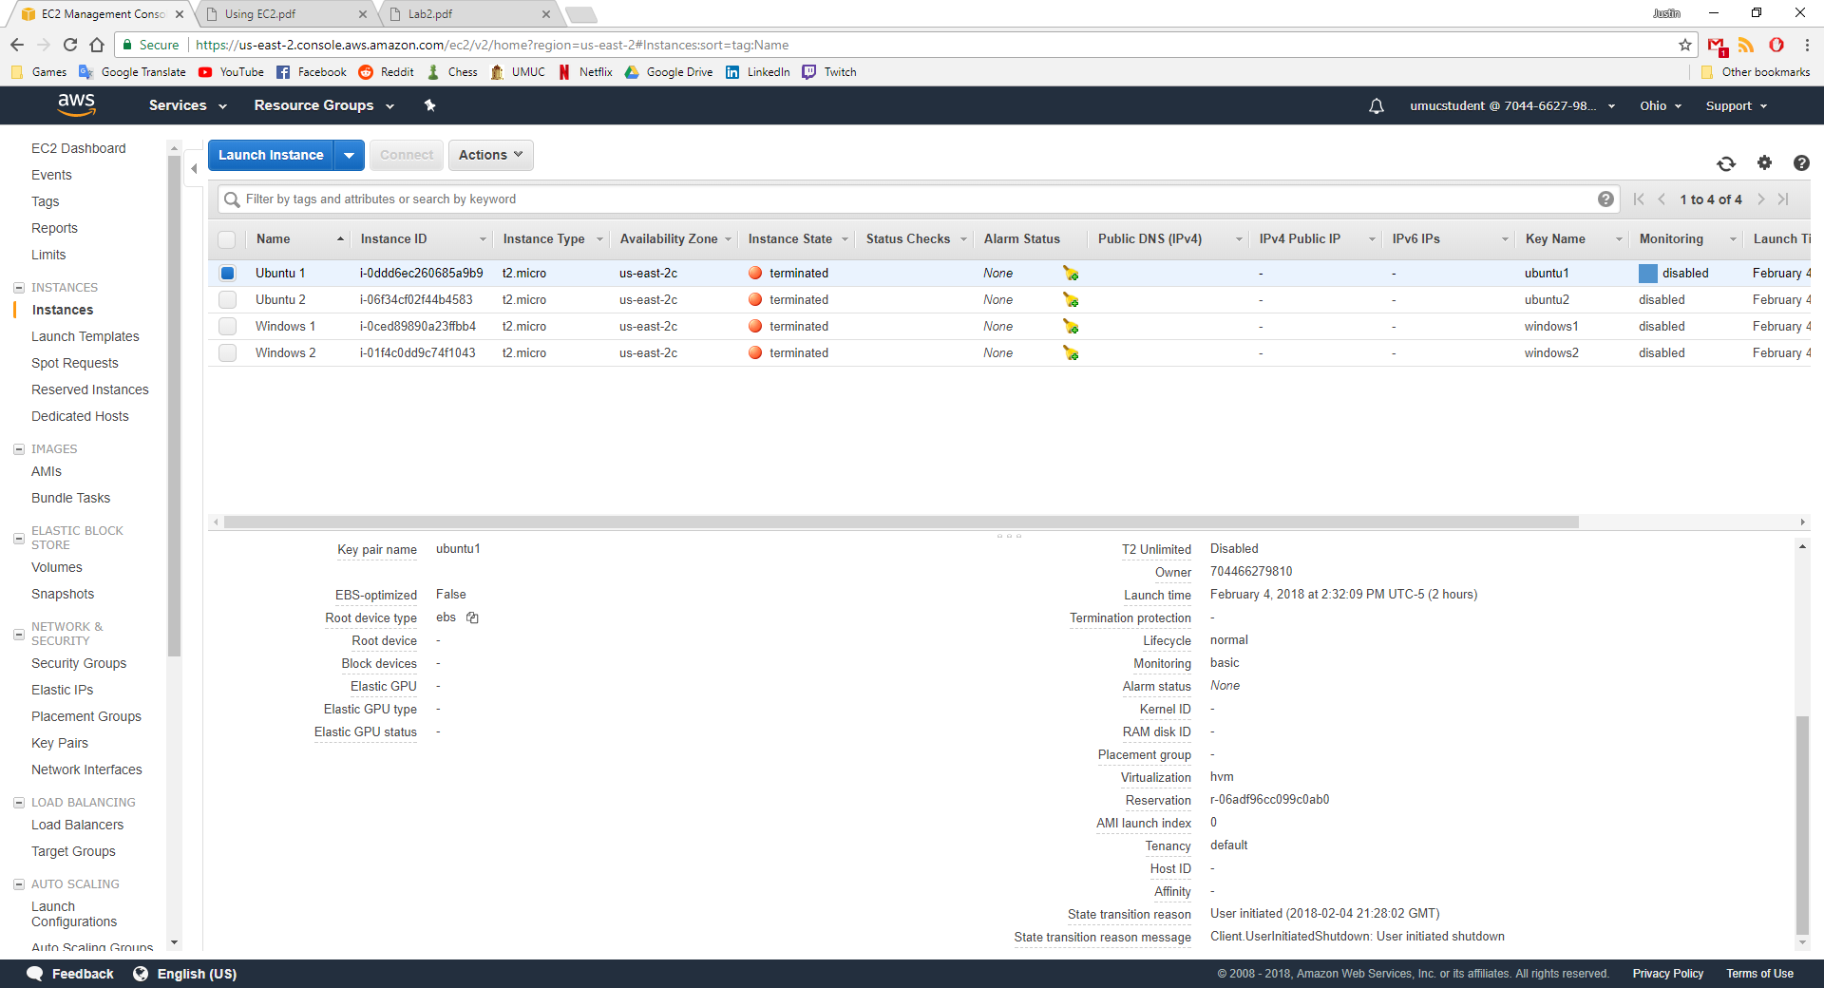

Figure 80 - Ubuntu2 terminated instance

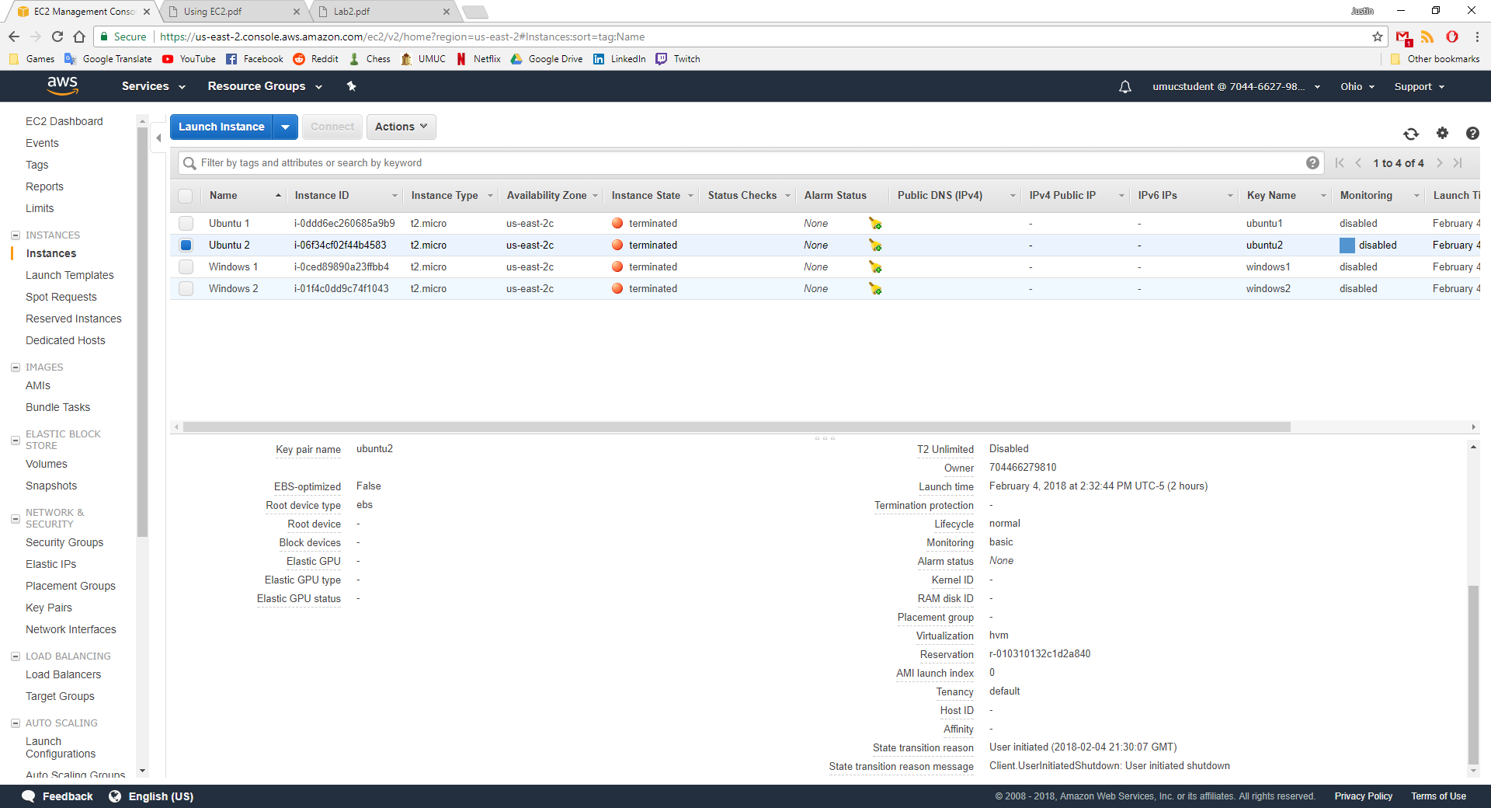

Figure 81 - Windows1 terminated instance

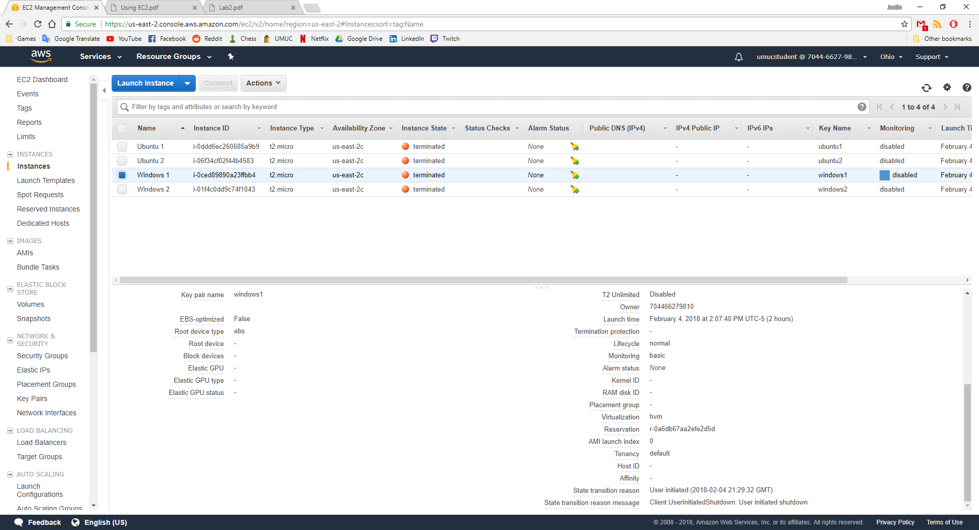

Figure 82 - Windows 2 terminated instance

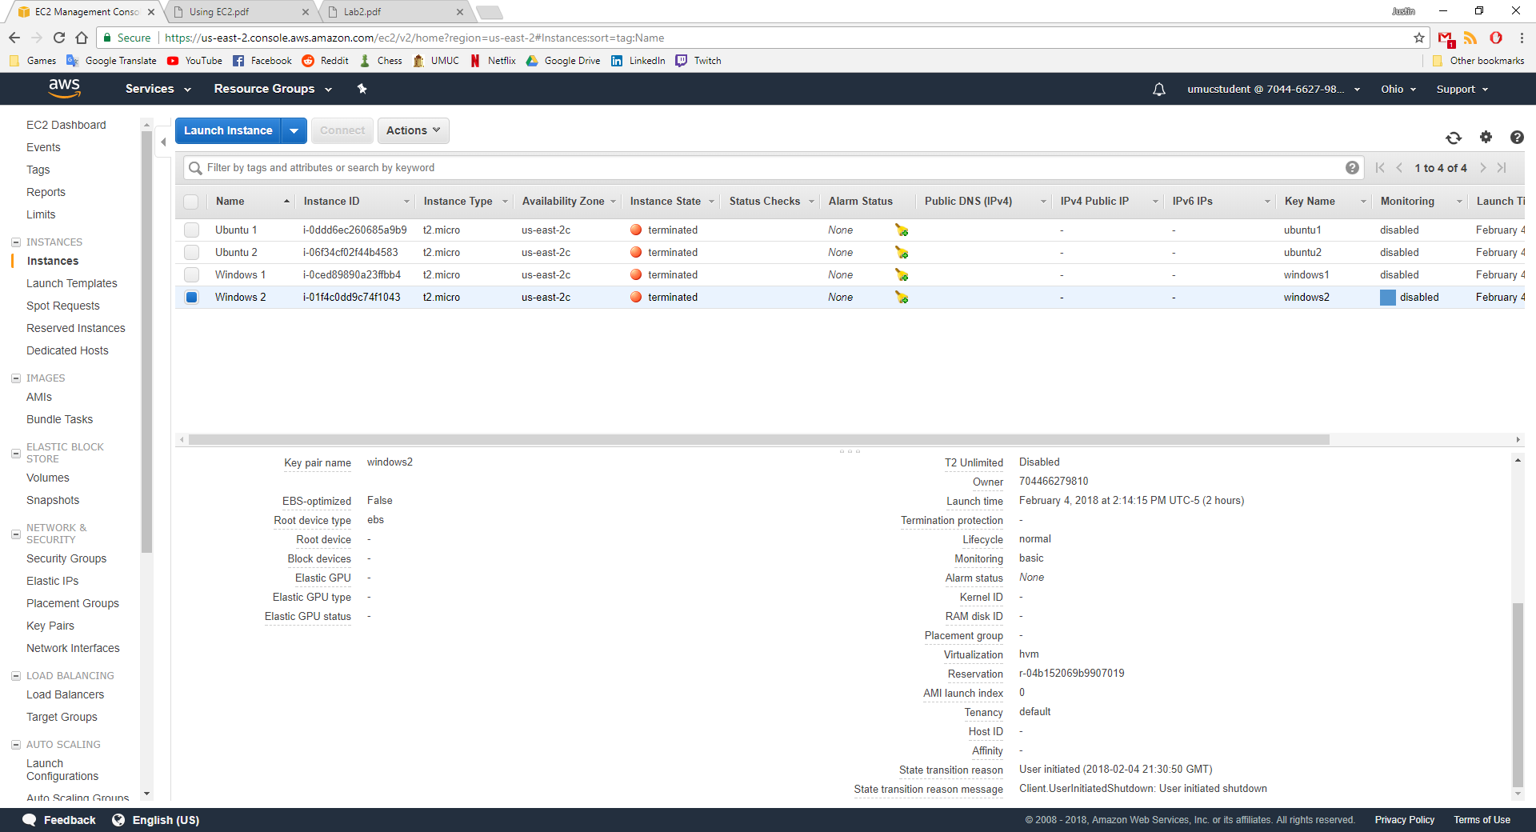

# References

Admin. (2011, September 11). *Amazon S3: How to Restrict User Access to Specific Folder or Bucket*. Retrieved from techtricky: http://www.techtricky.com/amazon-s3-how-to-restrict-user-access-to-specific-folder-or-bucket/

Amazon. (n.d.). *Amazon Simple Storage Service*. Retrieved from aws: https://docs.aws.amazon.com/AmazonS3/latest/dev/example-bucket-policies.html

Amazon. (n.d.). *An Example Walkthrough: Using user policies to control access to your bucket*. Retrieved from aws: https://docs.aws.amazon.com/AmazonS3/latest/dev/walkthrough1.html

Amazon. (n.d.). *User Policy Examples*. Retrieved from Amazon Simple Storage Service: https://docs.aws.amazon.com/AmazonS3/latest/dev/example-policies-s3.html

Scharf, J. (2013, June 13). *Writing IAM Policies: Grant Access to User-Specific Folders in an Amazon S3 Bucket*. Retrieved from aws: https://aws.amazon.com/blogs/security/writing-iam-policies-grant-access-to-user-specific-folders-in-an-amazon-s3-bucket/